Frome Riverside Market Yard Masterplan Design Brief
Background
Frome Town Council is developing a long-term Frome Riverside Vision to strengthen the area around the River Frome as a welcoming cultural, community and civic destination. The wider vision seeks to improve connections between the town centre, the river and key destinations including the Cheese and Grain, Black Swan Arts, Museum, Library and Market Yard, creating a vibrant place that celebrates Frome's creativity, heritage and independent character.
As the first phase of this wider ambition, the Council is seeking an architect-led design team to develop a masterplan design for a focused area centred on the Market Yard public toilets and the adjoining public realm.
Project Area
The commission will focus on:
- The existing Market Yard public toilet building, including the Changing Places facility.
- The surrounding public realm immediately adjacent to the toilets.
- The paved area running alongside the Library (the "Library Apron").
- The future, of the land on which the Loop de Loop building and the adjoining wall sit (it is considered that the Loop de Loop building is no longer fit for purpose)
- The pedestrian route connecting these spaces to the Westway Footbridge.
- The relationship between these spaces, the car park and the River Frome.
The intention is not to redesign the wider Frome Riverside area at this stage, but to develop a high-quality scheme that can act as a catalyst for future investment and demonstrate the aspirations of the wider Riverside Vision.
The plan below identifies the Project Area.
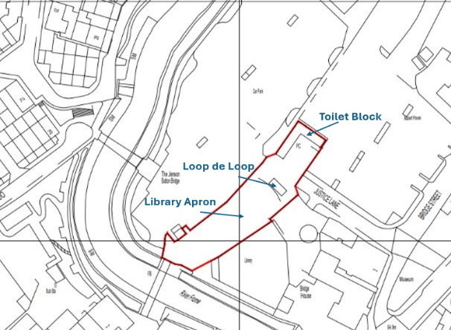

The Opportunity
This area is one of the principal gateways into Frome's riverside area which is central to some of Frome’s cultural organisations, including the Cheese and Grain, the Canoe Club, the Library, Black Swan Arts and the Museum. . Despite its strategic location, it currently suffers from poor legibility, fragmented public space, limited interaction with the river and challenges associated with anti-social behaviour around the public toilets.
The Council believes this presents an opportunity to create an attractive, safe and active civic space that encourages people to spend time in the area while improving connections between key cultural destinations.
Design Objectives
The successful team should explore how the project can:
- Deliver modern, welcoming and fully accessible public toilets, within the existing block, including the retention of the Changing Places facility.
- Identify and deliver a scheme for the rest of the Market Yard toilet building to include a retail unit, a market office and a storage space
- Improve the quality of the Library Apron as an attractive civic space.
- Strengthen visual and physical connections between Market Yard, the Library, the River Frome and Westway Footbridge.
- Create opportunities for seating, planting, play, gathering and informal community use.
- Improve accessibility and wayfinding.
- Celebrate Frome's identity, creativity and riverside setting.
- Increase biodiversity and climate resilience through landscape design.
- Support cultural activity, markets and everyday town centre life.
Designing Out Anti-Social Behaviour
A key objective of the commission is to address long-standing issues of anti-social behaviour associated with the existing toilet building and surrounding public space.
The Council is seeking design-led solutions based on the principles of active placemaking and designing out crime. Rather than relying primarily on enforcement measures, proposals should demonstrate how good design can:
- Improve natural surveillance.
- Increase positive activity and footfall throughout the day and evening.
- Create clear sightlines and welcoming spaces.
- Encourage a broader range of users.
- Improve perceptions of safety.
- Integrate the public toilets into a lively, well-used public space.

Outputs
The commission should include:
- A site analysis and opportunities plan.
- Concept designs for the redevelopment of the public toilet building.
- Public realm proposals for the Library Apron and surrounding spaces.
- Illustrative visualisations showing how the space could function.
- Outline landscape proposals.
- Design principles that can inform future phases of the wider Riverside Vision.
- A high-level delivery plan, identifying short-, medium- and longer-term opportunities.
Phasing and Development Approach
The Council recognises that the wider Riverside Vision will be delivered over time and is therefore seeking proposals that can be implemented in phases while contributing to a coherent long-term vision.
Design teams should identify a practical phased approach, considering how early interventions can improve the area immediately while enabling future redevelopment as funding becomes available.
Phase 1 – Public toilets and immediate public realm
The first phase should prioritise the Market Yard public toilets and their immediate setting. The Council is particularly interested in proposals that:
- Deliver modern, attractive and fully accessible public toilets, including the retention of the Changing Places facility.
- Improve the setting of the building through high-quality landscaping and public realm.
- Introduce screening, planting and other design measures that reduce opportunities for anti-social behaviour without creating hidden or inactive spaces.
- Apply the principles of designing out crime through natural surveillance, activity and high-quality placemaking rather than defensive architecture.
- Improve lighting, visibility and connections between the Library Apron, Market Yard and the Westway Footbridge.
Future phases – Reimagining the toilet building and surrounding apron
The Council is keen to explore how the existing building and surrounding apron could evolve into a more active destination that contributes positively to the wider Riverside Vision.
Design teams are invited to consider concepts that could include retained or reconfigured public toilet provision (Phase 1) integrated within the plans developed for the larger building area:
- A small permanent retail or café unit to provide activity, passive surveillance and an income-generating use.
- One or more flexible concession spaces for independent traders, pop-up businesses or community enterprises.
- Possibly a central covered atrium or courtyard that creates a welcoming, animated public space and improves natural surveillance.
- Active frontages facing both the Library Apron and Market Yard.
- Opportunities for outdoor seating, planting and cultural activity linked to the surrounding public realm.
Frome Town Council welcomes innovative proposals that demonstrate how the toilet building can become an attractive civic asset rather than a stand-alone public convenience. Designs should explore how a mix of uses can increase footfall, improve perceptions of safety and support the long-term vitality and connectivity of this important central access point to some of Frome's cultural organisations.
Any proposals should be flexible enough to allow delivery in stages, ensuring that investment is made in the initial phase supports, rather than constrains, future development and provide the first tangible step towards delivering the wider Frome Riverside Vision for Frome.

