Community Grants Terms & Conditions
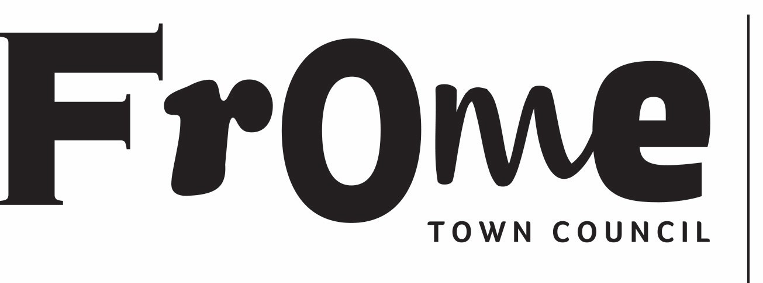

Frome Town Council has a reputation for being bold and ambitious. Our vision is of a town that is sustainable, inclusive and prosperous, with a community that is resilient, happy and able to shape its own future. The golden thread running through our work is building Frome’s economic, social, and environmental resilience - ensuring our town can weather wider challenges.

The Council Plan 2025-2027 states five Council Priorities:
- Grow Community Wellbeing
- Support a Thriving Town
- Cultivate Environmental Sustainability
- Improve Assets and Infrastructure
- Be a Bold and Effective Town Council

Our Community Grant Programme is designed to boost capacity in the local Community Organisation sector and support delivery of these aims and vision. We welcome applications from organisations whose projects address an identified gap in services and opportunities for residents in Frome. Each year we will specify themes that we’d particularly like to support, although other applications will be considered. The Community Grant programme runs alongside a wider offer of support such as training and fundraising advice to better enable local organisations and community groups to work towards long term sustainability. We expect applicants to have done sufficient research to be confident that their proposal is not a duplication of existing offers and, where appropriate, to collaborate with organisations whose aims and objectives or audiences overlap.

Not for profit organisations who have a constitution and a bank account with two signatories can apply for an FTC Community Grant of up to £3k to cover or part fund projects, activities, and organisational costs. In exceptional circumstances the Grants Committee will consider applications of up to £5k. Please note If your application is for more than £2k that the same project will not qualify further funding from FTC within a two-year window.

The process

Expression of Interest Stage

Applicants are required to complete a short Expression of Interest (EOI) that outlines their project idea in brief and confirms eligibility (see below for criteria). The Grants Committee will assess EOIs and successful projects will be invited to complete a full application. Once invited to apply, a support package will be available from the Communities Team to help shape project proposals and answer questions. Only applicants who have been through the EOI stage will be eligible to make a full application.

Resident Advisory Panel
The Grants Committee will be joined at the full application stage by a diverse panel of an equal number of Frome residents known as the Advisory Panel. The Advisory Panel will bring fresh perspectives into the process, being drawn from across the local community to include:

- People with lived experience of inequality or exclusion.
- People who have worked with others who have such lived experience and therefore have an understanding of the barriers they may face.

Following a short training process, the Advisory Panel will score all applications in the same manner as the Grants Committee and therefore 50% of the scores will be generated by the panel. Although the overall scores strongly indicate the strength of applications, other factors are taken into account and final decisions rest with the Grants Committee.

Essential eligibility criteria:

- Grant applications will only be considered where:
  - The project or activity directly benefits residents within the parish boundaries of Frome
  - The project is not funded by any other means by FTC
- The organisation is a not-for-profit structure and has its own bank account with at least 2 authorised signatories
- Grants cannot cover costs that have already been incurred
- The organisation must be non-party political and non-profit making. Individuals will not be funded
- Applications from organisations and services which receive other sources of government and local government funding must demonstrate how the project differs from their core services and how the wider community is involved (for example schools must provide evidence that the project is not for the primary purpose of teaching its students)
- All supporting documents are required to be submitted with the application form, including an up-to-date Safeguarding Policy
- The applicant must abide by all relevant laws and regulations - Frome Town Council reserves the right to request sight of the organisation’s policies

Full applications will be scored against the following criteria:

- Evidence of need for the project
- Impact for Frome’s residents
- Approach to partnership working
- Accessibility or the removal of reasonable barriers to participation
- Evaluation of impact
- Legacy planning

Decision making

The combined scores of the Advisory Panel and the Grants Committee will guide decision-making. The Committee will also take into account other factors such as an organisation’s access to unrestricted funds as evidenced in their accounts, or resources such as number of staff members. The Grants Committee will have final decision-making responsibility.

Decisions to award grant funding will be taken at a public Committee meeting. The full list of applicants and their projects will be summarised, Councillors will hold a short, closed discussion and then return to the public setting to vote on which projects will be awarded grant funding and the amounts. Organisations are welcome to attend but will not have the opportunity to answer any questions or make any statements – the Expression of Interest stage having allowed for clarification and detail to be shared ahead of the submission.

Terms and Conditions

Grants awarded by FTC are public money, collected as part of the precept and we are accountable to local people for all expenditure. When accepting the grant, you are agreeing to the following expectations:

- Monitoring and Reporting
Organisations receiving grants are required to report on how the funds are spent against the project criteria and budget breakdown. A form will be provided, and you will be notified of the date by which it must be completed and returned.

Frome Town Council representatives may request to visit the project and to talk to staff and participants to gain a better understanding of its merits and benefits to local people.

- Payment Requirements
  - Grants should be spent for the purposes stated on the application only
  - Frome Town Council reserves the right to recall any grant given to an organisation which ceases to operate during the financial year for which the grant has been given
  - The Council reserves the right to request a copy of invoices/receipts as evidence that expenditure has been incurred and underspends may need to be returned

- Publicity Requirements
  - Frome Town Council expects its logo to appear on published information about the funded project and to be mentioned in press and associated publicity and will ask for evidence to be provided for monitoring purposes
  - For our own publicity material, the Council may require photos with agreement from participants and may use the name of the organisation and project
  - Frome Town Council will publish grants awarded and summarise the projects using information contained in the grant application form.

If the Council becomes aware of evidence of dishonesty or negligence which could bring the reputation of Frome Town Council into disrepute, action will be taken, and the grant terminated.

The Community Grant Programme will be held once annually, with a closing date for full applications in the Autumn. In addition to our Community Grants, projects that involve Young People can apply to a Young People’s participatory grant making programme that closes in late Winter/Early Spring. See website for up-to-date information.

