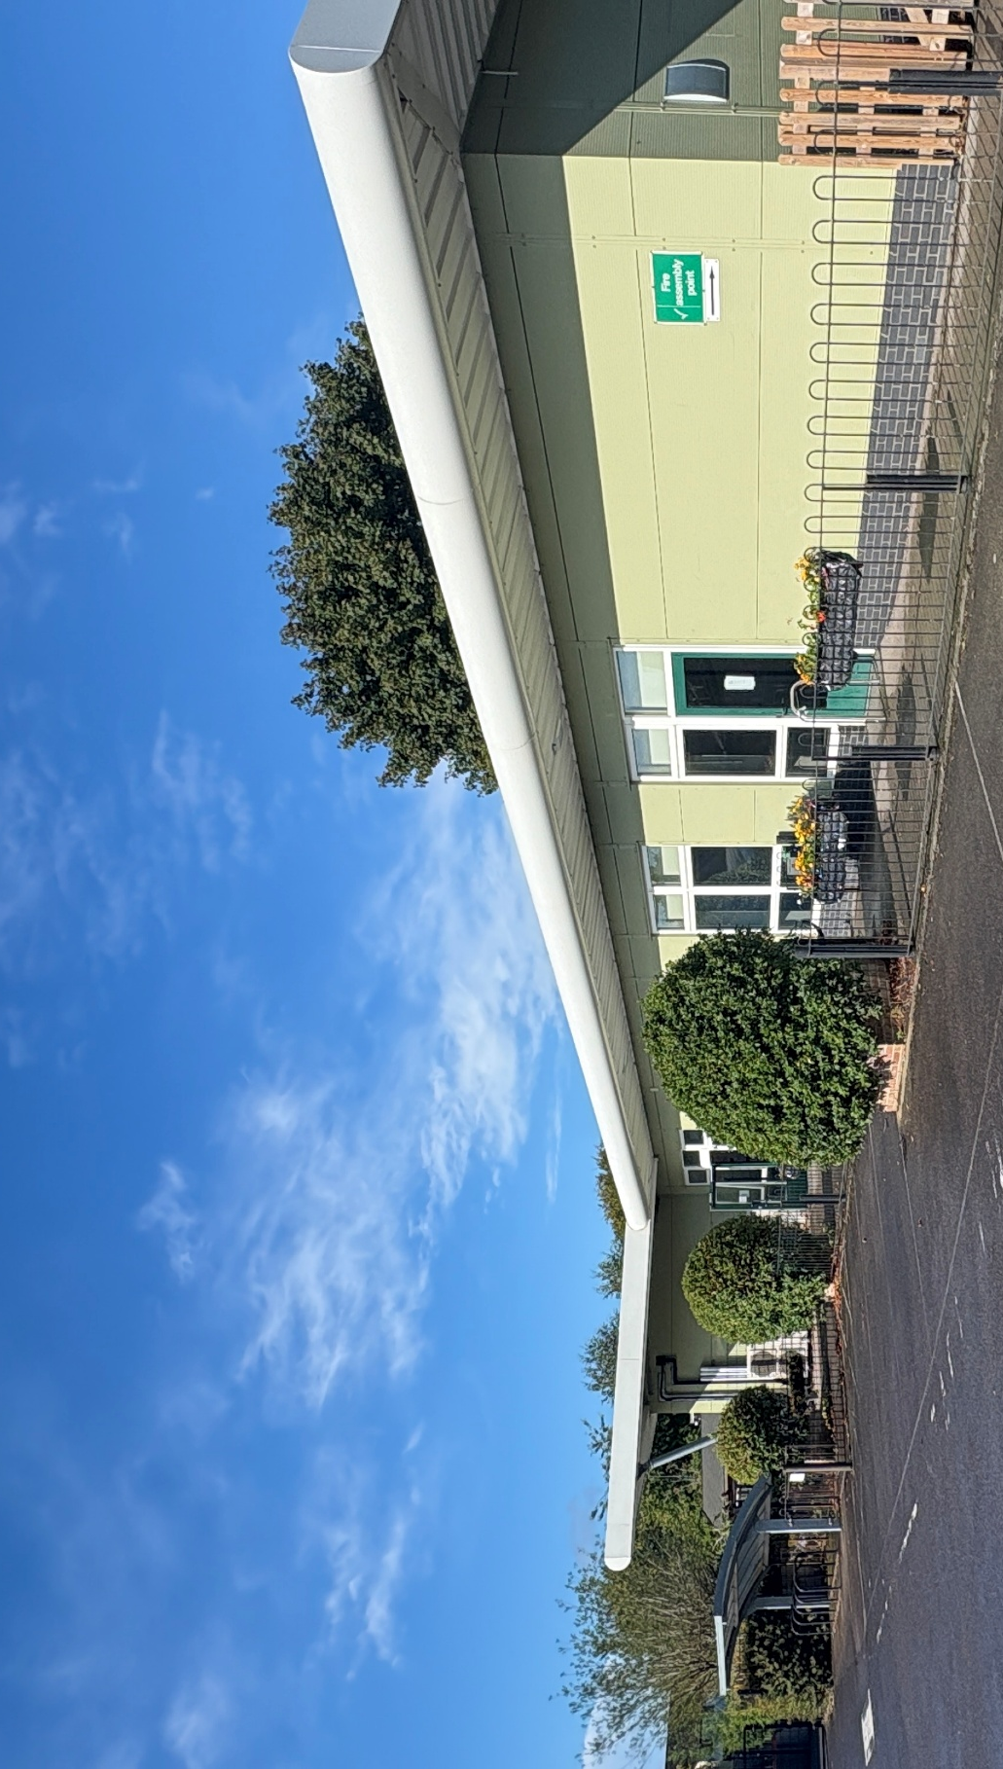
Childcare Business Opportunity

Nursery Information Pack


The Key Centre

Feltham Lane, Frome,

Somerset, BA11 5AJ

May 2026

Nursery Information

- Background

Frome Town Council (FTC) are looking for an established provider to deliver high quality childcare from the Key Centre:

- To establish an enabling and inspiring environment where children and babies can actively learn through all 5 senses. The provider would need to build excellent relationships with parents/carers as valued and vital partners in their child’s learning. Children’s voices, ideas and play will be at the heart of the nursery curriculum, ensuring child directed learning.

- To be committed to a culture of excellence, striving to achieve the best for the families and community it serves by adhering to the Early Years Foundation Stage 2025 Framework.

- To create a team of Early Years Practitioners in the nursery to be reflective, committed to high levels of safeguarding, and professional. To support continuous professional development and high-quality teamwork.

- To work closely with the local schools and partners to create a rich environment which values children as strong, confident, and independent learners.

- To focus on the all-year-round provision for children aged 0-4 years, and a particular focus on those aged 2 years and under, providing full day care supporting the Governments Early years & childcare agenda. To meet the community’s needs by potentially offering wraparound & holiday provision for children of school age.

Floor Plan

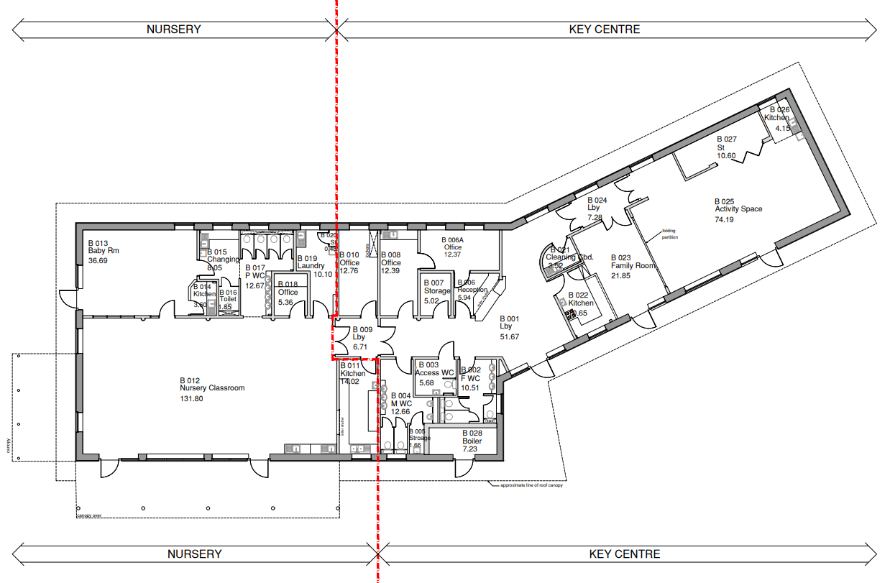

View floor plan in more detail

Please note: FTC has the freehold of the Key Centre building and Community Garden and Cabin. Current ownership of a section of the attached garden is with a third party. We would negotiate longer-term use of this space, however we are unable, at this point, to guarantee it as part of the leased area. There is a good sized, sheltered border that wraps the nursery with potential for development of play features, and the gardens and cabin would be available for a provider to hold sessions with the children.

Sufficiency Assessment

Childcare sufficiency assessment Key Centre May 2026

Potential Capacity & Income

Potential Capacity and Income

Financial Information

Building Running Costs

Information based on indicative figures which may vary

 |  | Indicative costs
Rent | To be set by landlord | To be agreed
Gas | n/a | n/a
Electricity | Tenant responsible for all costs. Nursery is metered separately | 50% share of current monthly average is currently £514.12
Water | 50% of metered supply to building | 45% of approx £1300 pa (£585 pa)
*Rates | Tenants responsibility
Building Insurance | 45% | 45% of approx £1,460 pa  (£657 pa)
Service Charge | £ 50% of all statutory compliance costs for the building including fire safety, legionnaires, alarm servicing and admin charge | Approx £2000 pa
Ground Maintenance – Nursery outdoor space | Tenants responsibility

*The incoming tenant will be responsible to contact the valuations team to reassess the rateable value and will be responsible for these from the day of occupancy.

Lease

We will draw up a Heads of Terms document with the incoming tenant when appointed. The lease would be a standard commercial lease. There is an expectation that the incoming tenant would bear their own legal fees in relation to this process.

- Expression of Interest to:

- Deliver Early Years provision from the Key Centre and to have signed the lease as a tenant.

- To deliver all year-round, high-quality childcare with a sustainable business model.

There is an intention for provision to be in place by January 2027, with some flexibility.

Please complete all sections of this form.

Key Centre - Expression of Interest to be returned no later than 5pm on Tuesday 14th July.

Contact Details:
Name of Organisation
Trading Name (if different)
Title
First Name
Surname
Position
Address
Postcode
Telephone
E-mail

1. Describe the nature of your current organisation. For example: length of operation, management, infrastructure, background and experience.

- If applicable, what is the legal status of your organisation? e.g. sole trader, limited company, partnership, etc. If applicable, please provide a copy of your latest trading accounts. If you are applying as an individual rather than on behalf of a nursery provider and therefore do not have trading accounts, please state this.

- Please state Yes or No to any of the below questions

If the answer to any of the below questions is ‘Yes’, please attach further details.
Have you, or if applying on behalf of a partnership or limited company have any of your current partners/directors:
Been in a state of bankruptcy, insolvency, compulsory winding up, administration, receivership, composition with creditors or subject to Relevant proceedings?

Been convicted of a criminal offence related to business or professional conduct?

Been found guilty of an act of grave misconduct in the course of business?

Failed to fulfil their obligations relating to the payments of social security contributions or the payment of taxes?

Been found guilty of:
- conspiracy to commit a criminal offence
- corruption
- bribery
- fraud or theft
- conspiracy to defraud
- fraudulent trading; or
- money laundering

4. Please provide details of your experience of managing childcare provision/s and if applicable, how you intend to manage the new nursery alongside any existing business?

- Please clearly show how the nursery will work in partnership with parents/carers, the local community and other organisations including the Key Centre community space and schools.

6. How will your proposal ensure the development of high-quality early learning and childcare for the Early Years Foundation Stage?

- Outline how you intend to make your childcare places affordable and enable parents/carers to access their free Nursery entitlement with flexibility.

8. Please demonstrate how you will be able to provide inclusive, innovative and forward-thinking childcare provision in the area that ensures the safeguarding of children is paramount.

9. Please explain how you intend to recruit staff with appropriate qualifications and experience and demonstrate an ongoing commitment to professional development.

10. Please detail what procedures you would put in place to ensure self-assessment and reflective practice. How will you monitor practice on an ongoing basis?

11. If shortlisted, please give contact details of two referees, who can be contacted to provide a reference on your ability to successful manage a childcare business.
Reference Contact details – 1

Reference Contact details - 2

I/we certify that the information supplied is accurate to the best of my/our knowledge. I/we understand that false information could result in my/our exclusion from the process. If applicable, this application must be signed by all partners/company directors/trustees or committee members.

Signature(s)

Print Names(s)

Date:

5. Selection Process

All applications received by the closing date will be considered by a shortlisting panel week commencing 13th July 2026. All applicants will be advised in writing of the decision, with successful applicants also contacted by telephone.

References will be taken up after the applicant has received notification of shortlisting.

If shortlisted, you will be required to provide a business plan which provides information on staffing and financial projections to provide an excellent level of nursery education and childcare. This business plan should include an overview of the organisation, management structure, marketing, proposed level of investment to set up the business and income and expenditure projections for initially two years.

Attached below is a business plan template and financial spreadsheets that can be used if required. Double click to open.

Each shortlisted applicant will be asked to present their proposal to a Selection Panel consisting of FTC Staff, Somerset Council Education Places staff and FTC councillors. Interviews will be held week beginning 10th August 2026.

Each applicant will be expected to present their proposals and business plan for approximately 30 minutes, a screen and laptop will be available for a PowerPoint presentation if required. Following this presentation please be prepared to clarify any aspect or answer any questions on your bid. It is expected that a maximum of 2 persons would be presenting their bid to the Panel.

6. Time Frame

Deadline for Tenders | Tuesday 14th July
Shortlisting | Wednesday 15th July
Interview | Week commencing 10th August

7. If you are successful:

You need to notify:
Ofsted: Application for new/dual registration, ownership/management. Please remember this could take time.

Somerset Council & Valuation Office – To register for business rates

Inland Revenue - To register as a business
Environment Health - To register ownership
Submit a funding application to the Somerset Council Early Years Funding team to be included in Somerset Directory of Providers - this is to enable you to draw down Nursery Funding. You are not able to do this until you are registered. It is not automatic. If you are not aware of the Somerset Early Years Provider Agreement the following link will take you to the Agreement and other useful documents:
https://www.somerset.gov.uk/children-families-and-education/early-years-and-childcare/early-years-providers-guidance-documents/

