**Frome Town Council - Tender Brief for Showfield Play Area Refresh**

The Play Area in the Old Showfield is Frome’s largest public play space, but due to a combination of unusually wet ground conditions, the materials used and the age of the play structures, nearly all the play installations have now been retired.

Frome Town Council are looking for an experienced and reputable Play Company to support the redevelopment of the play offer on the site. See link for location

<https://goo.gl/maps/thNuC8xXB5Y3mcRCA>

The development will consider the recommendations from the Frome Play Strategy <https://www.frometowncouncil.gov.uk/wp-content/uploads/2022/02/Play-Strategy-for-Frome-2021-2025.pdf.>

Our aim is to create a highly engaging play destination that surprises and inspires. We are encouraging play responses that are bold and innovative that focus on the play outcomes and experiences rather than delivering specific play equipment items.

Key principles from this strategy include:

* Ensuring inclusivity - play options included that promote access for all
* Encourage a sense of safe and social space, promoting permission to play and belonging
* Nurture incidental play
* Provoke innovation and adventure
* Offers variety and a range of risks and challenge

As additional context to inform the design process we have a summary of the views of users of the play area gained from a series of Community Engagement sessions in the summer of 2022 - see supporting document: <https://www.frometowncouncil.gov.uk/wp-content/uploads/2023/03/Old-Showfield-engagement-findings.pdf>

The references to individual play items are again a guide helping to inform thoughts about play experiences rather than literal suggestions for named play installations.

In addition to the play installations the scope of the tender includes undertaking the necessary investigations, design and ground works to address the pooling of water, through site reprofiling (design of the surfacing and sub-base) to eliminate a bottom bowl and providing run-off through standard land drains. Additional information providing a topographical survey and information on underground utilities will be provided as part of the package of information for tendering. The full scope of the works will be explained at an on-site briefing meeting on 27 April to be held at 11am at the Play Area.

Due to the high soil moisture content, play installations should consider the need for longevity, low maintenance and avoidance of rot (minimising/excluding use of wood structurally especially in ground, though wood cladding is an attractive and viable option)

The successful tenderer shall ensure that all equipment and surface finishes meet the necessary safety and play equipment standards. They will provide details of warranty and maintenance offered as part of the proposals.

The successful tenderer shall also obtain all necessary statutory approvals that may be required.

A successful tender should demonstrate:

* Value for money
* Proven track record of delivering at this scale
* Examples of a wide portfolio or works
* Experience managing ground works
* A track record of good budget/project management controls, consistently delivering to agreed timescales
* A design that has inclusivity and accessibility at its core
* A solution that is tailored to the setting (custom not off-the-peg)
* A design with a lifespan of at least 15 years
* A design that minimizes waste and promotes sustainability

The tender will include for the removal and disposal of all existing equipment, surfacing and other waste materials and installation of new equipment to include surfacing and making good as required. The site is located in the middle of a public park and consideration should be given to protection of the site and works during the construction and installation of the drainage, equipment and surfacing.

The awarded company will work closely with Frome Town Councils Officers, the council’s Employers’ Agents overseeing the works, and the Council Rangers.

Budget: Up to £150,000

Any questions can be sent to Rob Holden, Environment Manager [rholden@frometowncouncil.gov.uk](mailto:rholden@frometowncouncil.gov.uk) or Nikki Cox, Community Projects Officer [ncox@frometowncouncil.gov.uk](mailto:ncox@frometowncouncil.gov.uk)

Tenders to be submitted through the MyTenders Procurement Website by 5pm Friday 16 June 2023

**Aerial View of Park**

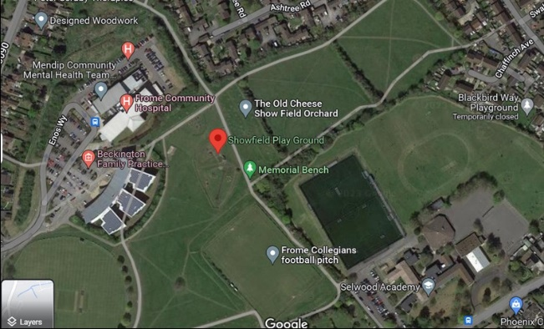

Map of Showfield and Play Area

