Green & Healthy Future for Frome:
Social Return on Investment Tender March 2023

Content

Overview 1
Project Background 2
Scope of the work 3
Timeline for outputs 3
Application 4
Appendix: 5
1. Programme details: 5
1.1 Our project on a page 5
2.1 The difference we want to make: 5
2.2 What will be delivered (overview) 7
Wider evaluation plan of our project 9
2.4 Project impact and measurement (evaluation work-package) 9
3.1.3 Highlighted targets 12
Rational for “Building a case for social investment” 14
Introduction 15
1. Assumptions behind building a case for social investment 15
2. Social investment in practice 16
3. What a case for social investment might look like 16
4. How to achieve this 17

Overview

Contract:
- Service Level Agreement with Frome Town Council (May/June 23 to April 2026).
- The contract will be reviewed on a yearly basis and continuation of the contract is subject to satisfactory delivery of agreed outputs.

Reporting: Directly to Green & Healthy Future Programme evaluation lead (employed through Frome Town Council on behalf of the partnership.

Timeline:
- Start delivery in May/June 2023, with completion by March 2026.

Contract Value:
- The maximum value of this contract is £39,000 over 3 years.

Location: Home/remote working, with visits to Frome (Somerset).

How to submit an application of interest: Applicants are invited to submit a breakdown of their suggested approach to this work, examples of other relevant projects and experience, and a quote for their fees to Owen King at oking@frometowncouncil.gov.uk by 16th May 2023.

Project Background

The Green and Healthy Futures Programme is funded through the National Lottery’s Climate Action Fund. The project is a collaboration between Edventure: Frome, Frome Town Council and Frome Medical Practice. The programme team began working on the project in March 2021, and are currently funded until February 2023. We have now won continuation funding to continue work to 2026.
The premise of our programme is that healthier people make a healthier planet, and a healthier planet supports healthier people, and that this also provides people with an opportunity to save on living costs. The programme will tell a new story that engages people who would not normally get involved for climate reasons alone. Alongside storytelling and community development activities the project will deliver a catalogue of community-led climate and health initiatives that can work sustainably in Frome.

Several work packages will be delivered over the next 3 years; each work package has a toolkit to enable ideas to be shared and replicated in other towns. For details on activities and toolkits see our website https://greenhealthyfuturefrome.org/.

Please see appendix A for more information on the work that will be delivered as part of this programme.

Scope of the work

The scope of this work is to produce a Social Return on Investment report for our programme activities and work-packages above as part of our in-house evaluation, working collaboratively with two full-time researchers employed by the programme.

We envision three main stages of work.

- Working with the in-house researchers to define a social value framework for whole work programme. Advising on how to collect appropriate data. Review of data previously collected. On-boarding the project team with the SROI approach.
- Ongoing support and advise to the in-house researchers with data collection, analysis and production of interim reports for individual work-packages.
- Data analysis and producing final report to be appended to our final evaluation report (which also include participatory research, qualitative research and a longitudinal study with support from a university).

Please see the appendix for our rationale and assumptions regarding building a case of social investment.

Timeline for outputs

2023:
- Produce SROI framework for our community-led climate & health co-benefits to be implemented in Frome and to contribute to the national community of practice. Support inhouse researchers to collect data.

2024:
- Produce SROI reports on individual work-packages to be included in toolkits, starting with Healthy Homes & Cycle Together.

2025:
- May 2025: Producing SROI reports on remaining work-packages, including Future Shed with its associated community-led initiatives, and Green Community Connectors.
- Estimate value of town-wide behaviour changes if possible.

2026:
- February 2026: Complete final report: including the SROI of the sum of our programme, with the aim to communicate the overall financial benefits & value of investing in building Green & Healthy communities.

Appendix:

1. Programme details:

1.1 Our project on a page

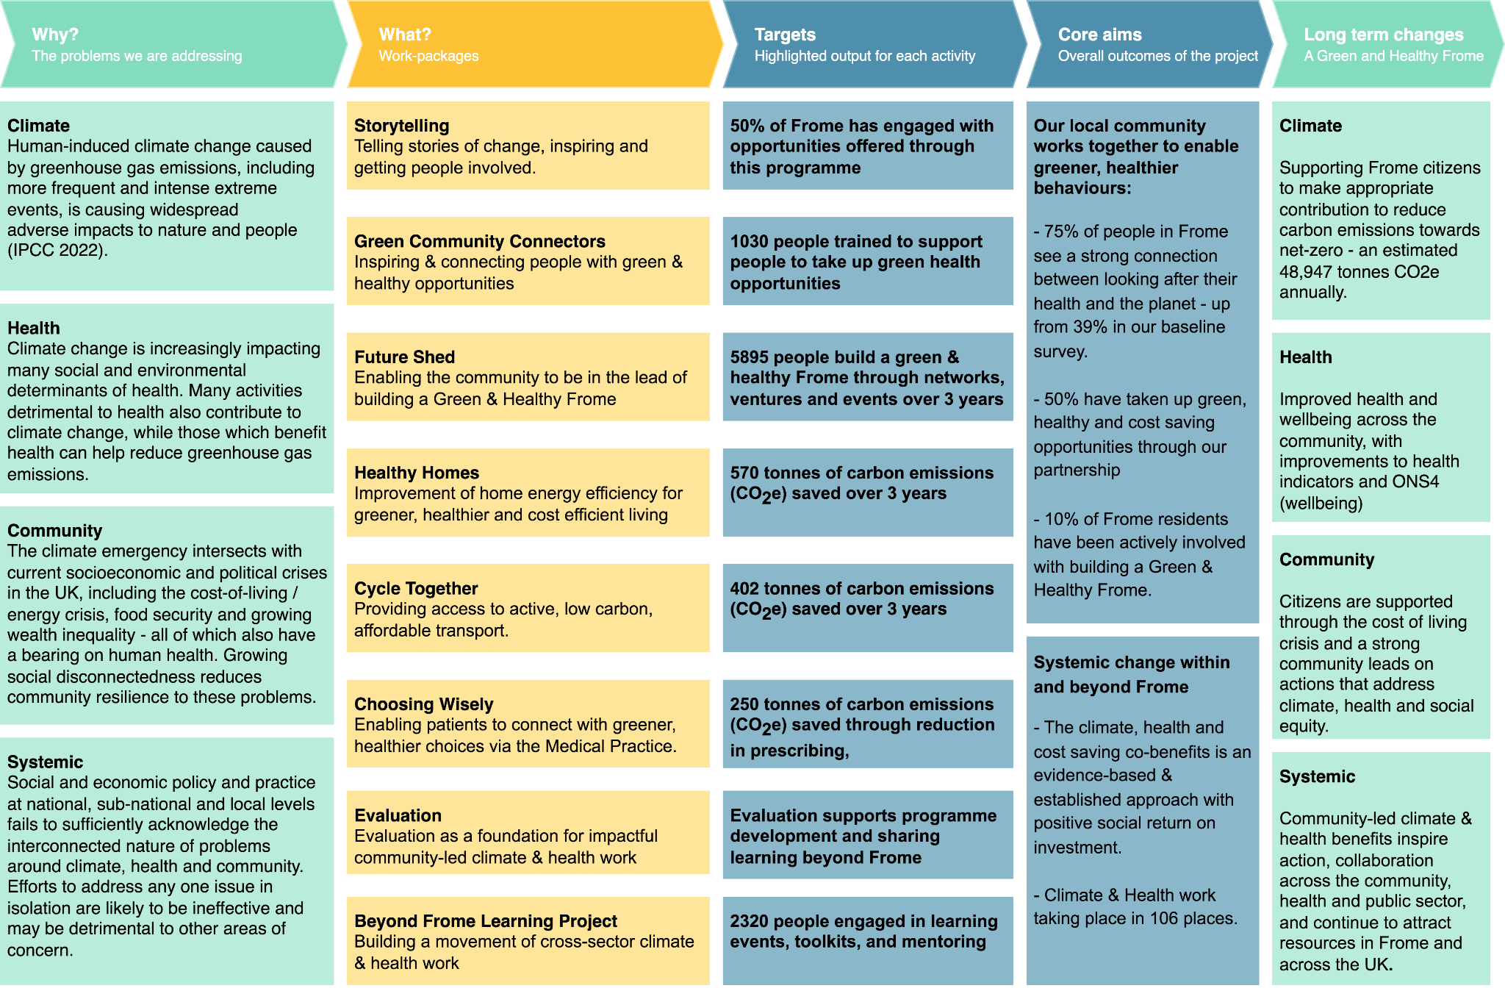

2.1 The difference we want to make:

2.1.1 Core aims & outcomes:

- Our local community works together to enable greener, healthier lives - now and in the future as part of our move towards net zero. The key behaviour that we aim to enable is for people to take actions that reduce carbon, improve their health and save money (by enabling them to have greener and healthier household expenditure).
What success would look like:
-> An estimated 75% of people in Frome see a strong connection between looking after their health and the planet - up from 39% in our baseline survey.
-> 66% have the knowledge and motivation to seek out opportunities to benefit their health, the climate and save money
-> 50% have taken up green, healthy and cost saving opportunities through our partnership
-> 10% of Frome residents have been actively involved with building a Green & Healthy Frome, reaching diverse, local populations.

- Facilitate systemic change within and beyond Frome by facilitating learning and sharing our approach. What success would look like:

  - The climate, health and cost of living co-benefits is an evidence-based and established approach, and draws investments from across the community, NHS and local government sectors.
  - We aim to have worked with organisations and cross-sector partnerships in at least 106 places, sharing our learning and contributing movement of community-led work focused on the climate, health and money co-benefit.

2.1.2 Long-term changes

We will help build a Green & Healthy Town - with changes across climate, health, community and the wider system.
We recognise that the long-term changes we envision will not be ‘produced’ by our partnership project in isolation - they are not targets we can claim to have achieved after 3 years. They give us direction and focus - and metrics we can use to measure whether we are moving towards our vision.
The change will depend on the wider system of local and national organisations and the behaviour of individual citizens - and that is why our key aims defined above can make an effective and significant contribution to achieve our vision - a green & healthy town.

Climate | Supporting Frome citizens to make an appropriate contribution to reduce carbon emissions towards net-zero - an estimated 48,947 tonnes CO2e annually.
Health | Improved health and wellbeing across the community.
Community | A strong community leads on actions that address the climate, health and social equity and can provide relief for the cost of living crisis.
Systemic | Community-led climate & health benefits inspire action, collaboration across the community, health and public sector, and continue to attract resources in Frome and across the UK.

2.2 What will be delivered (overview)

To achieve this, we are planning to deliver 9 integrated work packages and 4-5 annual residency partnership projects (residencies are detailed in the Future Shed work package), which fall into 2 categories:

(1) We will run activities that focus on enabling behaviour change.

In reference to the COM-B model of behaviour change (see below), our partnership provides the motivations, capabilities and opportunities to live greener & healthier lives.

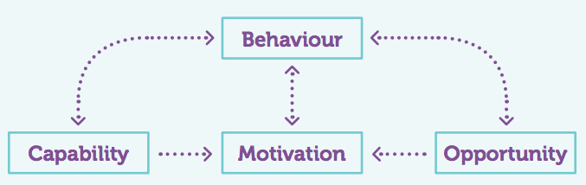

Our storytelling project, the Green Community Connectors, and Future Shed focus on building the motivation and capabilities for green & healthy behaviours whilst putting our community in the lead of this work.

These activities link with tangible opportunities for people to live green & healthy lives that our partnership & community network provides. Our work packages and partnership residencies focus on five key areas: housing and energy efficiency; active and low-carbon journeys; access to a climate friendly & healthy diet; community health and social prescribing; and changing patterns of consumption via re-use, sharing and waste reduction projects.

(2) We will expand our activities that focus on the development of our project in and beyond Frome to drive systemic change, including an in-depth evaluation project and a learning project to share our learnings and build on inspiration nationally.

The work package table below is a summary of all activities to be delivered:

Work-packages | Lead partner
(1) Enabling Green & Healthy Behaviours
Story-telling  Telling stories of change, inspiring and getting people involved. Including new participatory film projects and targeted storytelling to reach new audiences. | EDV
Green Community Connectors  Empowering & connecting people with green and healthy opportunities across Frome, and supporting work across Somerset, including a new programme for young women (Plastic Free. Period). | FMP
Future Shed  Enabling the community to be in the lead of building a Green & Healthy Frome, including new work with young people and 4 residencies in Year 1: Frome Food Network, Clothing & Textile Reuse Network, Frome Seed Library, ‘Declutter / reuse’ Frome. | EDV
Healthy Homes  Enabling people to improve their home energy efficiency for greener, healthier and cost efficient living, including a new innovative street-level community retrofit initiative. | FTC
Cycle together  Providing access to active, low carbon, affordable transport. Including collaboration with the newly formed Frome Community Bike Project CIC. | FTC
Choosing Wisely  Enabling patients to connect with greener, healthier choices via the Medical Practice, and sharing learning across the NHS. New communication resources will reach the whole practice population of 28000. Including activities in support of the evaluation and learning project. | FMP
(2) Driving Systemic Change
Evaluation  Comprehensive evaluation as a foundation for enabling impactful community-led climate and health work. New post within Frome Medical Practice and focus on Social Return on investment. | FTC + FMP
Beyond Frome Learning Project  Building a movement of climate and health work across the community, health and local government sectors, with a new focus on participating and facilitating learning nationally. | EDV + FMP

Wider evaluation plan of our project

2.4 Project impact and measurement (evaluation work-package)

2.4.1 Approach to evaluation
Formative evaluation enables the Green and Healthy Frome programme to benefit from continuous feedback and learning, informing the development of each initiative and maximising impact. Such a reflexive approach responds to the challenges of community engagement - understanding what works, what does not work, and promoting grassroots innovation. It also acts as a channel through which community voices can be heard and assume leadership in addressing problems of health and climate at a local level.
Evaluation is central to the purpose of the Green & Healthy Frome partnership. Its aims are:
- To evaluate the impact of our programme and project activities.
- To facilitate learning across the partnership and our national network
- To give voice to the community in the development of the project and informing systemic change.
- To demonstrate value to stakeholders across the community, NHS and government sectors as a key foundation to inspire action and affect systems change.

While evaluation was effective in the development phase of the programme, the role was significantly under-resourced, requiring a high level of unpaid input from the project team and staff. Evaluation across data streams from different partners is often complex and problematic, being subject to different data protection requirements and varying levels of available resources to collect and collate information. Our integrated and systemic approach also presents resourcing challenges - we focus on a wide range of behaviours and activities in a variety of settings - from housing to diet, community-led groups to our medical practice and patient data. Patient data has also presented GDPR challenges, and in-house evaluation capacity needs to be built within Frome Medical Practice.

As a result, we want to expand the evaluation work package for the full award, providing for additional hours and staffing to resolve these issues and achieve the above aims.
Robust analysis of key health and climate-related outcomes using qualitative and quantitative data informs ongoing and future initiatives. Communicating this knowledge effectively across diverse community networks, academia and government, the role provides evidence and tools for effective action in other settings. In doing so, we also engage critically with systemic issues that contribute to the climate and health emergency and offer examples of effective policy alternatives.
To promote our activities as effective tools to drive behaviour change, we also need to take an extended, longitudinal view to research the long-term effects. We understand how important this is because the direct carbon savings of activities can be small (for example replacing short car journeys with an electric bike), but the accumulative changes over 10+ years are significant. Continuing our whole town survey over the next 3 years, and doing follow ups on the work-package level will be key to answer how our co-benefit approach can help reach net zero.

Having demonstrated the ripple effect and systemic impacts of the programme to date, we know we can inspire action across the UK, within and beyond Frome. However, for our approach to be a viable prospect for funding projects across the wider UK and sectors, we need to show exactly what activities are effective, and the value of the changes we are proposing. Our commitment to building a case for social investment will demonstrate the social economies that funders can anticipate from green-health initiatives.

Our evaluation plan going forwards addresses the inherent challenges and complexities, and is based on three pillars (three evaluation angles delivered by 2 in-house members of staff, consultancy focused on social value and a university):

- A continuation of our project wide in-house evaluation post, supported by Plymouth University, and increased to 4 days per week to reflect the increase in project activity and complexity of work. It includes qualitative and quantitative methods including our whole town survey. For more details please refer to the following supporting information:
15 - Draft Evaluation plan diagram
16 - Draft Evaluation data collection plan spreadsheet

- A new evaluation post based at Frome Medical Practice to evaluate the project activities and the Practice’s wider sustainability work on patient health, carbon footprint and costs. Enumeration and data is essential to achieve systemic change locally and to help influence the health system beyond Frome. For details, view the draft Job description in the supporting documents.
17 - Evaluator Job spec at Frome Medical Practice

- Consultancy support to help build a case for social investment, and to articulate the cross sector financial benefits. For details on why we include a case for social investment view the draft tendering document in the supporting documents (specifically the appendix including our rational of focusing on Social Return on Investment:
18 - Tender for Social Return on Investment

2.4.1 Expected changes

The evaluation project will track our progress towards:
- Achieving our aims (see section 2.1 above for our core aims, and the targets we set against them for attitudes and behaviour changes.)
- Targets / outputs set by the individual work packages (see 3.1.2 Key Outcome / output targets in the project plan section of this document).
- Progress towards the long-term changes we wish to make, as presented below:

Climate | Supporting Frome citizens to make appropriate contribution to reduce carbon emissions towards net-zero - an estimated 48,947 tonnes CO2e annually. Our partnership makes a significant contribution towards it:  - We are able to attach informed estimates for carbon savings to approximately 30% of our work (parts of Healthy Homes, Cycle Together, Choosing Wisely, Plastic Free. Period)- a total of 1,229 tonnes.  - Further cumulative carbon reductions resulting from activities we cannot yet quantify and activities supporting community behavioural change. In particular, those resulting from lifestyle advice, Green Community Connectors training and initiatives emerging from Future Shed, which remain beyond quantification given resources available.
Health | Improved health and wellbeing across the community.  - Frome Medical Practice will track health improvements across a variety of health indicators as well as cost savings to the NHS and we expect to see above average improvements (compared to national outcomes).  - We will measure wellbeing outcomes through the ONS4 survey which enables us to compare it to national populations.
Community | A strong community leads on actions that address the climate, health and social equity and can provide relief for the cost of living crisis.  - Over 10% of our population in Frome actively engaged in building a Green & Healthy Town - through Future Shed and Green Community Connectors.  - Cost saving co-benefit of approximately £504,624 in total enables people to make long-term climate & health behaviour changes and helps with the cost of living.
Systemic impacts | Community-led climate & health benefits inspire action, collaboration across the community, health and public sector, and continue to attract resources in Frome and across the UK.  - A positive social return on investment - including carbon savings, cost savings to the NHS and community outcomes - helps attract resources to community-led, partnership based work on the climate / health / money co-benefit.  - Working & learning with 106 places / partnerships across the UK

3.1.3 Highlighted targets

The outputs from each work-package makes a contribution to the climate / health / community /systemic outcomes that we are aiming to achieve. Because of the complexity of our project and inherent in our co-benefit approach, we focus on one measurable effect for each work-package ‘(Highlighted effect/target), and name additional targets/outcomes.

Work-package  (Who leads) | Targets
Story-telling  (EDV) | Highlighted target:  50% of Frome engaged with opportunities offered through this programme, including new defined audiences (see EDI)  Other targets:  - 75% of people in Frome see a strong connection between looking after their health and the planet  - Inspiration to get involved with setting up or running community led climate & health initiatives.  - Overall comms reach of 70,000 each year
Green Community Connectors  (FMP)  With: Plastic Free Period | Highlighted target:  1030 people trained to support people to take up green health opportunities  Other targets:  - Promotion of all healthy and green activities across Frome - whole patient population (28,000)  - Influence systemic change in NHS at a local, district and national level  -Demonstrate value of behaviour change in primary care and trusted individuals in the community  -Increased engagement, knowledge and confidence in green and healthy activities (individual behaviour change).  - 1320 additional young people reached through Plastic Free. Period with associated carbon savings of 7 tonnes, wellbeing improvements and cost savings of £101250. Along with the attitude change and hook in to health and climate win-win, plus linking young people to other programme activities.
Future Shed  (EDV) | Highlighted target:  5895 people engage with building a green and healthy Frome through networks of action, new ventures and events.  Other targets:  - Increased social cohesion and community ties (measured through network activity)  - Increased capacity in local people to address climate via direct actions (measured through coaching and training uptake)  - Increased awareness of how to reduce carbon and increase health and save money, consumption of products and services.  - Direct carbon savings via new ventures supported
Healthy Homes  (FTC) | Highlighted target: 570 tonnes of carbon emissions (CO₂e) saved over 3 years (in addition to previous savings)  Other targets:  - £211,932 in estimated savings on energy cost for Frome residents  - 7677 reached through advice sessions, cases on the CSE system, home visits, installation of measures and retrofit plants, letters and texts from FMP.  - increased physical and mental wellbeing
Cycle Together  (FTC) | Highlighted target: 402 tonnes of carbon emissions (CO₂e) saved over 3 years by replacing short car journeys with bikes  Other targets:  - fewer car journeys over short distances  - 548 participants reached annually  - health and wellbeing improvement for participants  - air quality improvement  - visible uptake normalises a culture of cycling and builds consensus for infrastructure improvements.
Food at Five  (FTC / Fair Frome) | Highlighted target: 3640 healthy, climate friendly meals provided to people in food poverty.  Other targets:  - signposting to other initiatives such as Healthy homes leads to more money savings and health improvements  - food waste is reduced  - people on low incomes save energy costs  - health improvements for participants  - increased take-up of plant-based options
Choosing Wisely  (FMP) | Highlighted target: 250 tonnes of carbon emissions (CO₂e) saved through reduction in prescribing, including 54 tonnes from inhalers annually - based on changes between 2020 to 2022.  Other targets:  - Reaching at least 80% of our patients with climate & health messages (excluding small children), Practice population 28000.  - Further carbon reductions through deprescribing and travel - in development, we reduced over 60,000 miles of car journeys saved by switch to local blood testing  - Linking 2880 patients with Green & Health lifestyle interventions ( signposting to health connections 2280 annually and Health connections referrals 600 annually)  - Reach all 65 Somerset practices and through broader national connections a further cohort of 1000 practitioners.
Evaluation  (FTC) | Highlighted target: The climate, health and cost of living co-benefits is an evidence-based and established approach, and draws investments from across the community, NHS and local government sectors.
Beyond Frome Learning Project  (EDV) | Highlighted target: 2230 people engaged in learning events, toolkits, and mentoring.  Other outcomes:  - Engagement with 106 places who are planning to do climate & health work locally (including 65 Somerset medical Practices)  - Influence carbon and health impacts in other places

Rational for “Building a case for social investment”
Note. Provided at application stage.

Introduction

A key intent of our project is to affect systemic change - here in Frome and nationally. Our focus on systemic change has two angles - one is the focus on behaviour change, the other is on being a beacon to actively support other communities to do similar work.

Our work needs resources, and investment will need to be raised in the future - here in Frome and in other communities.

People and organisations already come to our partnership and ask how they can do what we do, how a similar project could be set up in their location. We can give them our toolkits, but these don’t answer some key questions that people ask us, including:
- How much will this cost? How long will it take? And what resources do we need?
- How do I convince potential funders it's worth their investment, time and resources?
- What evidence have you got to show it will work beyond Frome?

Creating a case for social investment as an explicit project 'deliverable' will answer these questions, which are essential for the legacy of this work in Frome and for replicating it in other towns.

1. Assumptions behind building a case for social investment

Building a case for social investment for our work is key to enable systemic change.

The assumption behind this is that systemic change happens when conditions are created for ‘the change’ to recur more often, until a tipping point is reached and the change is adapted throughout the whole system.

We can help build conditions for our work to recur in other localities by providing access to inspiration and knowledge about what works - by being a beacon - and crucially, to help others to mobilise resources in other towns aided by providing a case for social investment.

A further assumption is that there will not be enough resources for repeating the change sufficiently for social change to recur, unless we can demonstrate the co-benefits of this work, and how it provides value for money for the stakeholders of health, climate, local government and local communities.

2. Social investment in practice

Here in Frome, the co-benefits of our work for the climate, health and our community is being put into practice and understood, and that is why the local health service, local government, local community sector and the Climate Action Fund is pulling in the same direction. Both Frome Town Council and the Frome Medical Practice are putting up considerable match funding, mainly through unfunded staff time; Local residents are investing considerable volunteer hours to set up or run community led groups and initiatives; and we receive community funding. Resources are focused here because of the value they bring to the different stakeholders, and we invest time because we believe it represents good value for money and the time we put into it - but we do not have robust evidence for this.

Social prescribing provides an example for how a favourable social return on investment can lead to large scale adoption of its approach - it has paved the way for us.
Social Prescribing has a favourable Social Return on investment - it saves the health service more money than it puts in in most cases, according to a literature review and evidence summary of the Social Prescribing Academy. The Community Fund has also piloted several schemes and has concluded that "Social Prescribing has the potential to benefit individuals, the VCS and the health system by making better use of resources and giving people greater control of their own wellbeing.” - see Community Fund article here. There are now several examples of projects that are match funded through the National Lottery Community Fund and other community funders, as well as the NHS.

3. What a case for social investment might look like

We will calculate the social return on investment for our overall partnership project, and separately for each strand.
- Overall, we will be able to say what an investment of 1.5 million over 3 years can create in terms of monetary value - for the climate, for savings for the NHS, and the wider community, with outcomes including those aligned with the Community Fund - i.e., strong relationships, involvement with the local community, relief for the cost of living crises and helping people reach their potential.
- For individual strands & projects, our aim is to say that £1 of investment can create £x in value - including £x through carbon savings, £x through savings to the NHS, and £x through achieving community outcomes.

Other communities, and our own project, will then be able to use the calculations as evidence for raising match-funding from the NHS, local government, community funders and climate funders. This will be essential for community-led climate & health partnerships to operate in other locations - a stepping stone to systemic change, to a future where the notion of what is good for us, our health and our planet is firmly rooted in society.

4. How to achieve this

Achieving this will be challenging.

Building a case for social investment would firstly focus on reviewing proxy measures that already exist for the different impact areas, and exploring the gaps where more detailed, 'from scratch' calculations are needed.

Once we have decided on which proxy values we will use, we need to tailor our data collection to meet the requirements of the different proxy values.

Based on estimated reach of our partnership (21252 will be reached through activities over 3 years)
Based on engagement via Future Shed and Green Community Connectors.
Based on reaching 25% of 425 major cities and towns; the percentage is often cited as a tipping point for social change.
Frome’s carbon footprint is estimated to be 181,284 tonnes of CO2e (see 4- Frome Carbon Footprint. As citizens and as a community we can directly influence and reduce approximately 27% according to the Power to the People report (https://takethejump.org/power-of-people) or 48,947 tonnes here in Frome.
Frome’s carbon footprint is estimated to be 181,284 tonnes of CO2e. As citizens and as a community we can directly influence and reduce approximately 27% according to the Power to the People report (https://takethejump.org/power-of-people) or 48,947 tonnes here in Frome.
See 19 - Reach and output totals spreadsheet for details.
19 - Reach and output totals spreadsheet

