Green Breather Days – Information about the plan & FAQs

The Green Breather Days are a series of Saturdays between May and September where Frome’s town centre will be pedestrianized, encouraging people to explore the town centre by foot, boost support for local businesses and reduce Frome’s air pollution.
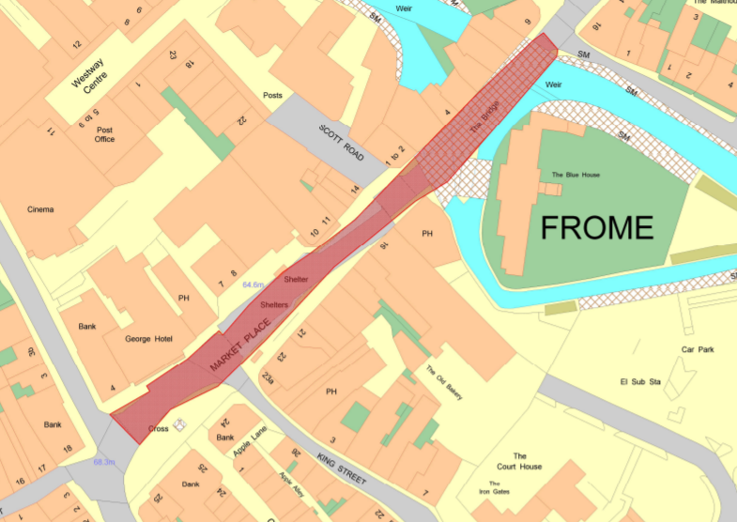
The road closure will extend along Market Place below Cork Street and up to the bridge. This means that Cork Street will stay open, and all of Frome’s carparks will be operating normally.
The space left by the closure will be used for activities. If you have any suggestions for what could be done in this space, please contact Alex Nettle at anettle@frometowncouncil.gov.uk
The road closure plans for Frome town centre

Frequently Asked Questions

- Will I still be able to use the buses?
Yes - the buses will be running as normal through the town centre, albeit only using one lane and using the Boots side of the road bus stop.

- Won’t closing the town centre cause more pollution because cars have to drive further?
We’re encouraging people to get out of their cars and walk and/or use public transport for an extra day every month. This is a great way to trial how we can reduce our transport emissions.

We will run extensive public consultation to make sure the public is clear about what is happening. If you still need to urgently use your car then diversions will be available.

However, we will also be monitoring the traffic levels and air pollution levels along the diversion routes as well as at the Market Place. This is an experiment to understand how we can help to reduce Frome’s emissions and improve air quality.

- Can we still use the carparks?
All of Frome’s usual carparks will be open as usual. However, please only use if you need to.

This will mean that Frome’s tourists should be largely unaffected.

- Don’t we already do this for the Market?
Yes, we do. But we want to explore other ways this space can be used, and encourage further reductions in car usage. We also want to use these to really see how people’s behaviour changes.

- How will this impact businesses?
We hope that the GBDs will be an incentive for people to come to the town centre and enjoy spending time in Frome. With activities in the temporary new space, we hope to create a buzz in the centre.

- It’s a great idea, but won’t really make a difference to people’s behaviour
We won’t know until we try! But this is part of a lot of joined up actions FTC and other groups locally have been taking to try and reduce Frome’s emissions and reach net zero by 2030. The GBDs play a role by demonstrating how spaces can be used differently without cars, and how this benefits the community.

