SIGN SCHEDULE FOR ROAD CLOSURE PROPOSAL FOR:
(INSERT MAP here and mark with numbers or symbols where you plan to put out signs. Use the sign chart below to indicate which signs you are planning to use. Include your first aid station. Indicate both the extent of road closure and diversion route)
MAP OF THE AREA:

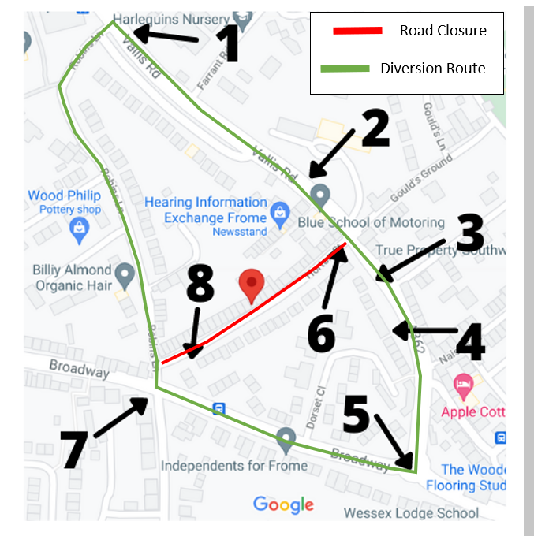

MARK ON MAP | SIGN | MARK ON MAP | SIGN
6 and 8 | 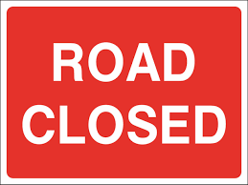  Freestanding 1050*750 | 1 | 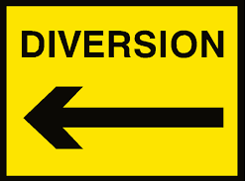  Freestanding 1050*750
2 and 4 | Freestanding 1050*750 | 5 and 7 | 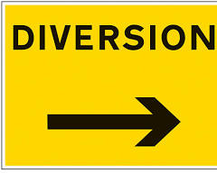  Freestanding 1050*750
3 | 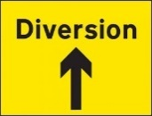  Freestanding 1050*750 |  | 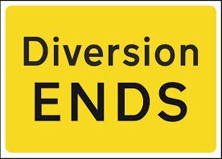  Freestanding 1050*750
 | 