Climate Change Decision Wheel Guidance

As part of an ongoing commitment to tackling the Climate Emergency and how it should influence strategy and policy, all decisions should incorporate the Decision Making Wheel to inform the decision making process. This is designed not to be a resources intensive exercise but to prompt thought by both the project leaders and decision makers. The wheel is shown below:
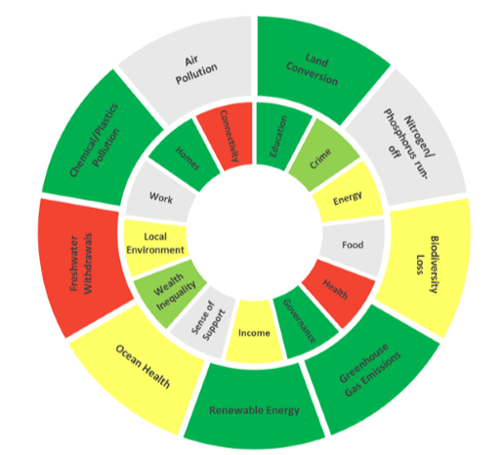
There are 9 outer environmental sections and 13 inner social sections. The tool is designed so that these sections are considered in conjunction with each other and that the wider effects of proposed initiatives are brought into the decision making process. It is also a tool to prompt thought on how a project can further benefit the residents and environment in Cornwall. It is of benefit to undertake the exercise as early in the project as possible in order to mitigate the effects of any adverse implications that are discovered during the process. The wheel should display a mitigated position as that is the suggested course of action that decision makers will be basing their decision on.
The sections of the wheel should be considered in turn and assigned an impact level. The impact levels are as follows:
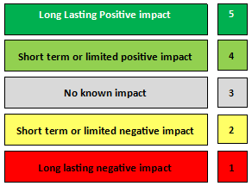
The ratings given should be based on the following guidance:
Long lasting positive impact - Does the action resulting from the strategy, policy or project mitigate current negative trends in either environmental or social sectors? Will the impact be long lasting and have an effect that could be measured over time?
Short term or limited positive impact - This is positive but could be a limited in its effects or one with a short lifespan.
No known impact – Will not affect any discernible positive or negative change in either social equality or environmental impact. This may also reflect a net neutral effect with equal positive and negative overall outcomes.
Short term or limited negative impact - Will your actions have a short term or limited negative impact that will be mitigated naturally or by project actions over time?
Long lasting negative impact - These are actions we most want to avoid, where there will be a long lasting, measurable decline in one of the sections of the wheel.
Definitions of each section of the decision wheel are detailed later in this document.
A brief narrative should be included alongside the wheel which draws attention to any points that project leads would like to clarify or provide further explanation on. Mitigations can also be detailed here. Other sections of any supporting report should also provide more details relevant to the ratings given in the wheel where appropriate and in particular any specific risks or mitigations that are relevant to the decision.
Using the Excel Tool
To produce the image of the wheel itself is produced in a Microsoft Excel tool which you can find HERE.
The tool is designed to be simple to use. When opening the Excel file, to ensure the macros (coding embedded in the spreadsheet) work correctly, please ensure you have clicked “Enable Content” on both the yellow security warning strips that will appear one after the other as below:
You should decide upon the ratings as outlined above for each section of the wheel and then, using the drop down menu, choose the appropriate number.
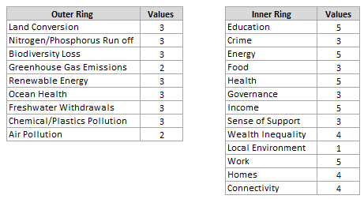
Once you have entered a rating for each section, you should click the “Run” button below the ratings boxes. When you click the “Run” button the wheel should reflect the ratings you have entered. You can then copy the image of the wheel from the spreadsheet (right click, copy on both the inner and outer wheel diagrams) and paste it into your document.
The finished wheel and narrative should be presented together in the key information section of the paper. It should look like the below example:
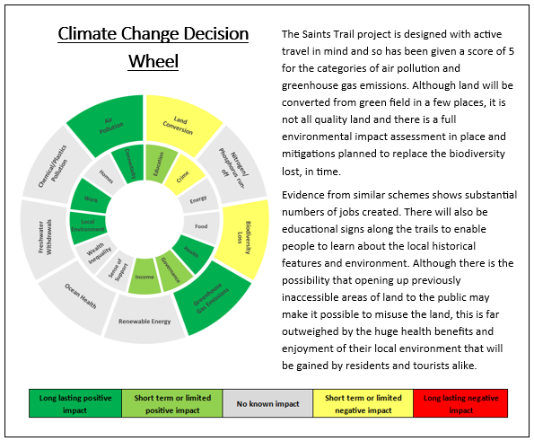

Decision wheel section definitions
For help with interpreting or assigning a rating to any of the sections of the wheel, please contact Mark Holmes (Carbon Neutral Cornwall Manager) in the first instance.
Environmental sections
Greenhouse gas emissions: This refers to any direct or indirect impacts of the project or initiative that may increase or decrease net greenhouse gas emissions being released into the atmosphere as well as any sequestration efforts. Please consider if residents or staff will have increased journey times if they would usually travel by car, increased use of machinery or equipment that is powered by a fossil fuels or any land use change. The learn more about this subject, a useful resource is the Carbon Trust website: www.carbontrust/home/
Air pollution: Air pollution happens when harmful or excessive quantities of substances that are harmful are present in the air. The World Health Organisation (WHO) produce guidelines concerning concentrations of fine particulates, nitrogen dioxide, sulphur dioxide, carbon monoxide and ozone. They also cover indoor mould, dampness, emissions of gases and chemicals from furnishings and building materials, emissions from cooking and heating stoves and clean fuel use. If you think your project or initiative would result in an increase, either long or short term, of any of these in the atmosphere, then air pollution will need to be considered as a factor in the decision wheel. You can find further information and signposting on air pollution on the Government’s air quality policy paper webpage: https://www.gov.uk/government/publications/air-quality-explaining-air-pollution/air-quality-explaining-air-pollution-at-a-glance
Ocean health: Any project or initiative that will mean a change to the biodiversity contained within the ocean, locally or indirectly further afield, would need to be considered as an impact for the decision wheel. This could include for example, pollutants released into or removed from the ocean, habitat creation or loss or any action that would affect the wildlife and their natural behaviour. This would also apply to land immediately bordering the ocean which may be used by wildlife that mainly inhabit and therefor are part of the eco-system of the ocean e.g. sea birds nesting on cliffs or seals who would also inhabit beaches.
Freshwater withdrawals: This focuses on any change to the hydrological regime of an area including the removal, recharge, contamination or remediation of fresh water from any natural water source. This will include local river catchments, sewerage systems and ground and surface water aquifers. Construction projects will generally have a negative effect on this unless specific remediation measures are in place.
Land conversion: This would include any change in the use of land. Land can exist as:
- Developed, meaning heavily covered or underlain by manmade structures such as urban environments (including brownfield sites).
- Managed, meaning devoid of human structures but still managed by human activities such as farmland but not forestry areas.
- Wild or semi-wild, meaning land that is inhabited only by plants or wildlife and sees minimal management and no manmade structures located in or under it. This can include forest, open moorland and marshland.
Any changes would need to be considered in the decision wheel assessment.
Nitrogen/Phosphorus run-off: Any activity which would affect the concentration of nitrogen or phosphorus in the natural environment would need to be considered in the decision wheel. This will include soils and water courses. This will only apply if as part of your project, chemicals like fertiliser or pesticides will be applied to land or crops or if there is significant land use change leading to changes in run-off in river catchments. This may be relevant in projects within the developing agritech industry or any construction projects.
Chemical/plastics pollution: This would include any increase or decrease in the amount of chemicals or plastic waste materials in the natural environment. A waste management strategy for the project or initiative could mitigate this risk.

Biodiversity loss: Any change which could affect the amount or type of biodiversity present in the natural environment, even on a small scale, should be considered as part of the decision wheel assessment. There are many things which could affect biodiversity including pollution of the natural environment, habitat fragmentation or removal of plant life or structures where wildlife is already in place, excess noise, proximity to developed land or human occupation or the introduction of any other wildlife as an indirect effect of development elsewhere. Some of these things are well covered by planning guidance on protected species but not all. The Council’s Biodiversity Guide has more information on how to conserve or promote biodiversity: https://www.cornwall.gov.uk/biodiversityspd
Renewable energy: This could include an increase in the provision of renewable energy directly or putting in places measures that could mean the likelihood of renewable energy being used or created is increased for the future. Putting in place infrastructure or policy which will allow renewable energy generation or use in the future can be considered a benefit. Conversely implementing any development or policy that would impede the implementation of renewable energy generation or use in the future could be considered a negative impact.
Social sections
Connectivity: This is about people's ability to access services and the changes that can affect that. Changes that result in individuals or groups having greater access to the facilities they need or want, and at a time of their choosing can be considered as an impact on connectivity. This includes electronic links via the internet or a physical link like a new or more frequent public transport link. This would also include the relocation or expansion of an existing facility to be closer to a group of users that currently has less access.
Homes: This includes the provision of new or increased provision of existing properties. This also includes an increase in the standard or properties available to residents or a change in the systems or policies surrounding the housing of residents. It can also include the construction or action towards providing the infrastructure that will allow development of land for housing.
Education: This is not limited to mandatory education or skills but is meant in the widest sense of the term. The imparting of beneficial knowledge to any resident or visitor which could increase awareness of a subject or promote further learning or employment can be classed as education. This could be on a cultural matter for example a heritage project, or the provision of facilities at a school or adult education organisation. This could also include outreach projects to raise awareness of services provided or a public health campaign.
Crime: If the project or initiative will affect the likelihood of a crime being committed or the ease with which a crime could be committed, it should be considered in the decision wheel assessment. This includes increasing access to areas where there currently is none. It includes all types of crime, from the misuse of rural highways to the vandalism of property or harm to residents. This could also include cyber-crime and the possibility of identity theft and fraud. A possible mitigation may be the use of CCTV or extra IT security measures.

Energy: This refers primarily to issues of fuel poverty. If the project or initiative may increase access to more efficient heating, insulation or domestic fuel sources then that should be considered as a benefit in the decision wheel. This could include construction of more fuel-efficient homes or the retrofitting of energy efficient products such as insulation.
Food: If the project will in any way effect resident’s access to or supply of food, this would be a consideration for the decision wheel. This would also include the type of food available e.g. access to healthy choices that are affordable. Any action that would affect access to food retail outlets should be considered here.
Health: This covers a wide range of implications from health education to access to medical facilities and pharmacies. The health domain should consider any impact that could affect residents’ access health services such as GPs, emergency treatment, mental health provision, health related equipment provision, prevention advice and public health campaigns, pre and post-natal care, residential or day care facilities. This will cover both mental and physical health issues including passive environmental effects on health through issues such as noise and pollution.
Governance: There are two aspects to this domain. Governance in this instance can apply to projects or initiatives that affect the amount of personal efficacy a person has in relation to decisions or actions taken by any organisation. It can also apply to projects and initiatives that would impact levels of community involvement and input to development. As an example, the project may be one designed to implement a system whereby a community is allocated an amount of funding to use as they wish in relation to highway schemes. It could also mean the opportunity to develop a project or initiative as a result of public consultation or engagement during the planning process.
Income: This focuses on working conditions for individuals, particularly rates of pay, job satisfaction and job security. This is not to be confused with the provisions under ‘Work’, which focus more on creating a good environment for businesses.
Sense of support: This domain refers to the prevention of isolation for individuals within our communities. If the project or initiative will result in increased support for those groups at higher risk of isolation, that would be considered a benefit. If the project would increase factors that are contributors to isolation e.g. lack of transport links, anything that would prevent the formation or continuity of community/outreach groups and facilities, that would be considered a negative effect. This would also include the discontinuing of services provided to those groups at higher risk of isolation like day care facilities or organised activities. Opportunities for building a sense of community through celebrating cultural heritage would also be considered a benefit.
Wealth inequality: Wealth inequality refers to the variance between the highest and lowest earners in an area. If an action would shift the balance so that this gap would widen, that would be considered a negative effect. Actions that would affect the types of industry and employment sectors in an area may have the effect of widening or closing the gap between the highest and lowest earners. Asset ownership should also be considered – does this project help build the wealth of the community through increasing the assets owned by it such as housing stock?
Local environment: Access to the local natural environment is a key wellbeing factor for residents. Any change which affects how easily or how often residents can access their local environment for leisure or educational purposes would be relevant to this domain. An example would be the creation of an access route to public land or the protection or enhancement of woodland.
Work: This focuses on the business environment, specifically the conditions for new businesses to start up, grow and flourish. The provision of good quality employment opportunities is a key goal for our economic development and the wellbeing of residents. This is not necessarily concerned with the level of pay but more the variety of options for employment and the job satisfaction that can be achieved by residents.

