Frome Town Council Draft Transport Strategy
This draft document outlines Frome Town Council’s strategy relating to transport in the town. The strategy reflects Frome Town Council’s commitment to improving access with a focus on promoting active travel and moving away from fossil fuels.
Background
Frome Town Council has committed to becoming a fossil fuel free town by 2046. This includes transport which accounts for an estimated 14kWh per person per day (excluding aviation). There is a global movement away from fossil fuel powered transport and the UK has committed to phasing out petrol and diesel vehicles by 2040, with other countries such as Norway aiming for 2025. In Frome there are air quality issues in several areas which impact on health and wellbeing. As bus services are cut and with an ageing population there is an increased need for local facilities and services. Frome’s Neighbourhood Plan see transport as a key issue and delivering ‘integrated sustainable transport options is a key aim of the Frome Neighbourhood Development Plan.’

Vision
Frome is a thriving, healthy town where the need to travel has been minimised by providing a wide range of local leisure, education and work facilities. Most people walk and cycle wherever possible and a network of walking and cycling routes have been developed. Transport hubs such as the station are integrated with other modes such as walking and bike use / hire. Car sharing and increased use of electric vehicles have also helped to improve air quality. The majority of vehicles are electric, powered by renewable energy.
Frome’s Transport Strategy Summary
This draft document sets out some of the priorities and key actions that could be undertaken by Frome Town Council and other key stakeholders such as Somerset County Council and Mendip District Council. Transport infrastructure and behaviour change require significant investment and resources and is not an area that town and parish councils usually cover. However, by partnering with other organisations, securing external funding, lobbying transport providers and thinking creatively there are a range of opportunities in which Frome Town Council can play an important role.
Other key stakeholders are: Somerset County Council who are responsible for highways, bus subsidies and other areas. And the local planning authority, Mendip District Council also have huge potential to influence the area positively through promoting and enabling sustainable development which provides a mixture of housing and work opportunities, local services, limits car use and supports shared mobility. Other organisations such as the national cycling charity Sustrans and Carplus could provide expertise and resources for the area.
To summarise, Frome’s transport priorities in order of importance are:
Reducing the need to travel
The could be done through: supporting local job creation, increasing access to work space, supporting local opportunities for education and training, supporting provision of local facilities, working with businesses to promote local sourcing and teleconferencing.
Support and promote transport based on a hierarchy of walking and impaired mobility vehicles, cycling (including electric bikes), service delivery vehicles, community transport (with disabled access), other public transport (including rail), taxis, private cars (including car clubs and car sharing), and haulage vehicles. This could include working with businesses and schools to promote active travel, promoting lift share and car clubs, supporting bike training, developing the community car scheme, lobbying for better public transport provision for the town and working with developers to encourage home-zone layouts which reduce car use and enable active lifestyles.
Support and propose sustainable transport schemes, including connecting people to key destinations by walking / cycling links. This could include support for completing the Missing Links cycle route between Frome and Great Elm, an electric bike hire scheme, promoting walking and cycling as part of Discover Frome.
Work towards integrated transportation hubs to provide linked exchange to different ways of travel including Park & Ride / Stride to reduce traffic on market days.
Seek comprehensive transport assessments and green travel plans for all significant locations where a large number of individuals will need regular transport.
Encourage and support traffic management measures to reduce car usage, congestion, air pollution and noise and that enhance the environment, improve safety and promote sustainable modes of travel.
In order to facilitate these actions a wider piece of work to understand current travel patterns and needs is required.

Frome’s Transport Strategy – Setting the Scene

Planning and Neighbourhood Plan
The delivery of integrated sustainable transport options is a key aim of the Frome Neighbourhood Development Plan. The priorities for delivering these are:
• Completing Frome’s Missing Links in the National Cycle Network 24
• Improving access to and along the River Corridor, in line with the Frome River Strategy.
• Enhancing the environment around and access to Frome Railway Station
• Providing safe and accessible bus and coach stops
• Identifying clear and safe routes for pedestrians and cycling as part of the remodelling of Frome Town Centre.

The plan also outlines the need for a ‘Transport Plan’ for Frome. This would need to be developed in partnership with Somerset County Council who are responsible for travel planning, highways and transport strategy for the county.

Each of these elements will be explored in following sections.
Current Transport Patterns
There is limited data around current travel patterns for the area. The data that is available is from the 2001 census and only covers transport to work. This reveals that current travel to work is highly car dependent, of the 13,199 Frome residents that work, 72% drive to their place of employment.

Figure 1: Frome’s Travel to Work Patterns 2001
The 2001 census revealed that 3,714 people commute out of Frome for work and 2,749 people travel into Frome for work. The diagram below shows the number of people commuting to and from key areas.
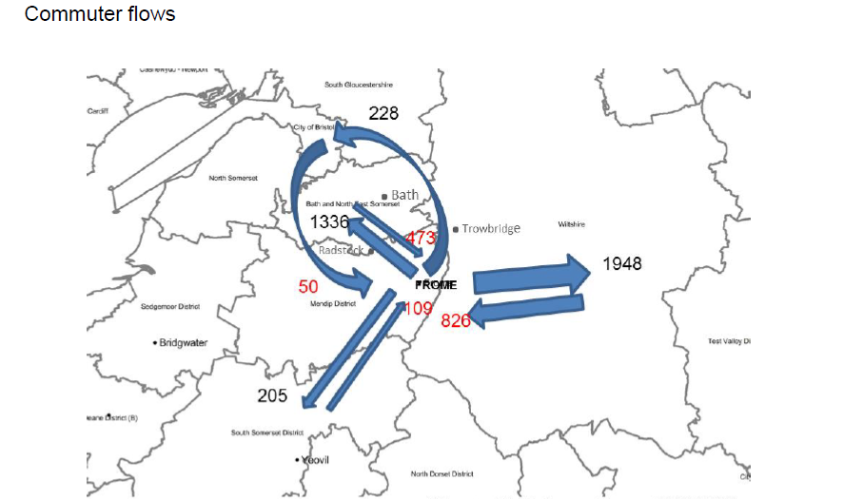
Figure 2: Travel to Work Commuter Flows to and from Frome

Understanding Travel Patterns
Understanding travel needs is key to enabling successful and sustainable mobility solutions. A larger piece of work, which looks at where the community travels to and from and when, would enable development of smarter transport solutions. Enabling the community to see and understand these flows would allow exploration of a range of opportunities around shared transport. This could be done, for example, through tracking movement using smart phones to provide a space /time map. Travel diaries and focus groups could also contribute towards this understanding of travel patterns and development of solutions. However, this work would need to be budgeted for.
Action: Frome Town Council and Somerset County Council to explore opportunities for commissioning further transport data. Frome Town Council to hold a ‘shared mobility’ workshop to explore new approaches nationally.
Air Quality
High car usage has significant health and environmental impacts. The Royal College of Physicians estimates that air pollution causes 40,000 excess deaths every year in the UK. The EU legal limits on Nitrogen Dioxide are 40 ugm-3 (micrograms per cubic metre). Defra data for Frome reveals that some areas such as the Butts and Market Place are getting close to this legal limit:
Location | 2015 | 2016
Christchurch Street | 30.23* | 30.88*
Portway | 27.88 | 28.15
Monmouth Drive | 12.93* | 14.59
Market Place | 35.09 | 33.68
38 The Butts | 37.59 | 36.53
87 The Butts | 26.70 | 22.61
Garsdale / Vicarage Street | 28.45* | 25.35
*insufficient data for annual mean
Figure 3: Air Quality Data for Frome

Frome’s Transport Strategy – The Way Forward
The following section outlines a range of actions that could be undertaken to enable a transition towards a clean, healthy town. The actions are summarised in the Transport Strategy Action Plan which accompanies this document. The key stakeholders in this strategy are Somerset County Council who manage highways, approve travel plans and manage the transport strategy for the county; Mendip District Council who are the local planning authority and Frome Town Council who is taking an active role in working to reduce air pollution and encourage active travel.

Reducing the need to travel
Reducing the need to travel in the first place is key to reducing emissions and air pollution and needs to be the priority. Strategies to do this include:
- Supporting and enabling local employment and training opportunities within the town and through new developments. Frome Town Council support with an Apprenticeship Co-ordinator based at Frome College and promote local employment and training opportunities. Ensuring that developments provide a mix of employment and residential accommodation would help to significantly reduce the need to travel. Mendip District Council have a key role to play here.
- Promoting and enabling home working
- Promoting flexible working and hot desks, for example, at the Town Council and at hubs throughout the town and through the council’s ‘Good Business’ visits
- Promoting local leisure and vacation opportunities – this can be done through ‘Discover Frome’, Frome Tourist Information point and other platforms.
- Supporting and promoting a range of local services.
Key Actions: Frome Town Council to promote and support flexible working, to provide hot desks and support local employment and training opportunities. Frome Town Council to work with Mendip Planning Board and Somerset County Council to ensure new development has a mixture of housing and work opportunities and local services.
Active Travel
Active travel such as walking and cycling have the greatest positive health impacts and can also help to significantly cut local congestion and pollution. For example, studies have found that children actively travelling to school are able to concentrate better, learn more quickly and generally do better at school. Studies in Denmark found that adolescents who regularly take part in physical activity are more resistant to drug and alcohol addiction.
In May 2017 Frome’s Missing Links held an Active Travel Challenge with local schools. The month-long programme monitored levels of activity to school, provided activities for schools including bike breakfasts, bike fixing, new scooter storage, photo competitions and prizes. The programme resulted in an impressive average increase in active travel of 23% (Table 2).
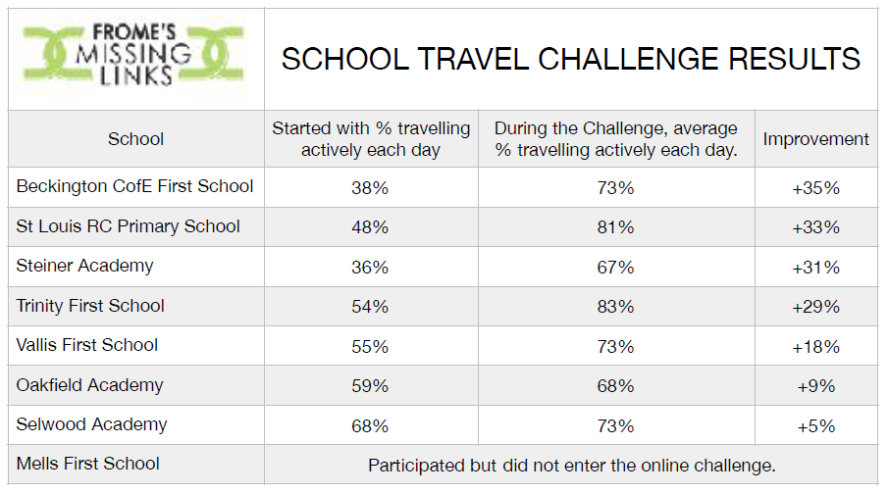
Table 2: Missing Link Active Travel Challenge Results May 2017
Continuing to promote and create a culture of active travel to school is vital to secure the long term benefits of the project.
Key Action: Frome Town Council to help organise and promote the Active Travel Challenge in 2018.

Walking and Running
Enabling behaviour change is a complex process. However, there are some actions that Frome Town Council and others could take to encourage more walking. This could include:
- Working with planners and developers to encourage ‘walkable neighbourhoods’ that have services such as shops that people can reach on foot,
- providing walking maps to residents and visitors potentially through an integrated transport map
- working to enhance and promote walking routes, promote walking groups including walking buses and walking ‘taxis’, walking holidays and walking activities
- promote initiatives such as ‘Good Gym’ which enable people to get exercise while running useful errands for the local community
Key Actions: work with Mendip Planning Board to ensure that walkability is integral to all future developments – this is key to reducing travel impacts and increasing healthy, active lifestyles.
Cycling
The health benefits of cycling are well documented and include increased fitness, reduced heart disease and cancer and improved mental health. One of the key barriers to cycling in Frome is the hilly nature of the town and the lack of cycle paths. However, electric bikes provide one solution to the hills. Frome is lucky to have three world leading cycle businesses in the town: The Bicycle Academy who train people to build their own bikes, Cycles Maximus who produce electric rickshaws and Charge Bikes – Frome Town Council will link with these organisations to promote cycling the area. Here are some other ways we could enable and encourage more cycling:
- work with Somerset County Council and developers to increase provision of safe cycle routes around the town and integral to new developments. Frome needs more defined and signed cycle lanes and safer access at key junctions.
- In 2012 Somerset County Council commissioned a ‘Future Cycle Network Mapping’ report which outlines a range of opportunities to create better cycle routes in the town. These recommendations in this detailed report should be implemented where possible.
- provide e-bike hire and information about e-bikes – Frome Town Council recently invested in two electric bikes which are available to the community for hire. We also link with Frome Medical Practice to signpost patients to the scheme and get a discount on hire.
- hold a cycling festival and support events such as the Cobble Wobble in partnership with the Bicycle Academy.
- provide cycle maps, cycle parking and cycle training. The Frome cycle map is currently out of date and could be updated to include walking routes and potentially bus and train connections too.
- explore opportunities to set up / promote a cycle courier scheme in Frome.
- explore opportunities for bike rental and development of a ‘Frome Bike’ to enable easier cycling up hills in partnership with the Bicycle Academy.
Key action: Frome Town Council to work with Somerset County Council and Sustrans to develop a network of safe cycle routes
Frome’s Missing Link: There is a huge opportunity to significantly increase cycling to and from Frome via the Missing Link. The Colliers Way Sustrans Cycle route already links Great Elm to Bath, however, a budget of around £600,000 needs to be found to complete the works needed to link up Great Elm to Frome.
Key action: Frome Town Council to work with partners to help secure funding for Frome’s Missing Link

Reducing Fossil Fuel Car Use
Enabling and incentivising a reduction in car use is fundamental to the council’s commitment of moving away from fossil fuels by 2046. This could be done through:
- Working with developers to minimise parking requirements using the Home Zone concept which provides safe spaces for people to meet and children to play. Somerset County Council have an important role here in reduce parking ratios for new developments. This will enable and incentivise car clubs and car sharing on site.
- Enable car sharing through enabling and promoting car clubs
- Promoting lift-share (see below)
- Installing and promoting installation of electric charge points for electric vehicles. With the UK set to phase out petrol and diesel cars by 2040, the infrastructure for charging electric vehicles will need to develop significantly. In Frome there are already four public charge points: at the Cheese and Grain, Frome Medical Practice, Frome Football Club and a shared one at Frome Town Hall. A map of all charge points nationally is available at Zap Map.
Key Action: Frome Town Council to work with Somerset County Council to ensure new developments have low parking ratios, link with car clubs through space provision and Section 106 funding and include liftshare and other sustainable transport information in home information / welcome packs.
Liftshare
Whilst electric vehicles will help to reduce emissions, they don’t solve issues around congestion or parking and still take energy to produce. Sharing lifts is a simple solution to reducing car use and there are a range of on-line lift sharing platforms available. Analysis of the main providers (see Appendix A) reveals that Liftshare is potentially the most suitable for Frome. This is because it is the largest provider in the UK, already has people in Frome using it, charges less fees than other competitors such as Bla Bla Cars and is a not for profit social enterprise. Promoting a Frome scheme could help create a critical mass for lift-share in the area and incentivise more people to share journeys. Tailoring marketing would be important to ensure that lift-share complements rather than competes with local bus services.
Key action: Frome Town Council to promote Liftshare to Frome households and businesses
Community transport
Whilst reducing car use is key, ensuring that isolated communities and people with restricted mobility are able to access transport is vital to a healthy, happy town. Initiatives such as community transport are an excellent solution to this. In Frome this comprises primarily of:
- Mendip Community Transport who provide a ‘slinky service’ that Frome residents can book two weeks in advance. The Slinky 'demand responsive transport' service had almost 90,000 single passenger journeys in 2014/15
- Frome Community Cars – a Frome based volunteer driver scheme that provides lifts for those in need using volunteer’s vehicles set up by Frome Town Council but soon to spin out as an independent community enterprise

Key action: Frome to promote community transport and support Frome Community Cars to break even and become independent.

Bus
In Frome, as elsewhere, bus services have been withdrawn or under threat over the past few years. Cuts to government funding, privatisation which encourages bus operators to compete rather than co-operate, increasing bus fares and low density of population have all contributed towards this. However, buses serve some of the most vulnerable people in our communities, many of whom would be cut off if bus services are withdrawn. 43% of Somerset bus journeys (4.1 million) in 2015/16 were made by elderly and disabled concessionary passengers. At 17.7 per head, Somerset has the ninth lowest bus passenger journey per population in England and the lowest in the South West. However, bus usage has increased over the past 5 years to 9.7 million bus passenger journeys in 2015.
Buses also add significant value to the local economy. A recent study by KPMG on the value of bus services found that the economic, social and environmental return for each £1 spent on bus services range from £2.00 to £3.80 for revenue expenditure and £4.20 and £8.10 for capital expenditure.
There are some actions that can be undertaken to encourage increase use and work towards enabling financially sustainable services. This includes:
- Work with stakeholders and existing data to aggregate information around transport needs including: times, routes, cost
- Promoting current services, discounted tickets for Frome residents and interoperable smart card once it’s available
- Work with Somerset County Council to install real time bus signs (estimated cost £2000 per unit)
- Work with operators to develop express routes and / or trial new routes with Mendip Community Transport or Frome Minibuses, for example linking Frome railway station with Westbury station. Look at alternative branding for this such as Frome shuttle (avoiding the word ‘bus’)
- Explore opportunities for tourist buses to key attractions such as Longleat,
- Work with businesses and operators to link to key employment areas such as Commerce Park
- Link with Frome and Village Bus User Group to lobby Somerset County Council and bus operators to ensure continued support of key services.
- Provide an information hub for local transport including bus routes, volunteer drivers, car club, transport etc on the FTC website linking with Traveline, SCC’s transport information hub and Google Maps

Rail Services
Despite high usage rates service provision at Frome Station is very low and trains can be very crowded at peak times. The table below shows that train usage has increased by 71% between 2001 and 2011 in Frome with almost no increase in services.

 | Population  2011 census | Rail services | Station use #  2004/5 | Station use#  2013/4 | 10 year  Growth in station use
Frome | 26, 203 | 8* | 92,126 | 157,584 | 71%
Gillingham | 11,871 | 23 | 359,176 | 415,612 | 15%

Frome has 8 full services to Bristol via West Wiltshire and Bath. In addition there are a half a dozen short workings in non peak periods from/to Westbury, and three direct services to London Monday to Fridays.
# Entries and exits taken from ORR Station Usage 2013 - 14 Time Series.

Key actions include:
- Promote services, support additional providers such as Go-op and Community Rail
- Work with service providers to lobby for enhanced services, for example, continue current discussions with First Great Western around increased stock and services, and assist Somerset heritage railways in their plans to use the quarry train lines for passenger services
- Promote train usage, for example, through working with Somerset Rail Partnership to develop a Frome leaflet and include train and bus info in new residents welcome packs
- Explore opportunities for setting up a new local railcard

Future trends
With the huge increase in electric vehicles and the development of autonomous vehicles transport impacts are set to change significantly over the next decade. This is something the council should embrace and plan for. Electric vehicles are significantly less carbon intensive than petrol and diesel vehicles even when powered by non-renewable energy. Trials of autonomous vehicles are already happening in the UK and will mean households will not need to have their own vehicle. This will free up parking spaces and land and could enable more lift sharing.

Linking with Industry Experts
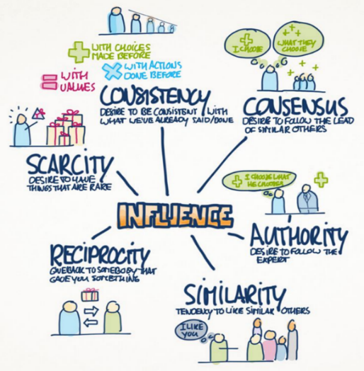
It is clear that there are many actions that could be undertaken to help enable the shift away from fossil-fuel based transport. Working with transport experts such as Carplus to develop our understanding of travel needs and inform our approach will be vital. Carplus’ transport methodology ‘Cocomo – Community Combined Mobility’ enables them to work with the community to identify travel patterns. Engaging with the community in a variety of ways at the research and planning stages ensures ideas are accessible to different types of people. Each stage is developed with Cialdini’s 6 principles of influence in mind (Figure 1) to maximise community engagement and ensure they feel part of the process.
Figure 1 Cialdini’s 6 Principles of Influence

Solutions developed through this methodology would include shared and peer to peer services enabling members of the community to become service providers and keeping a greater proportion of transport revenue within the local community. This could include: ‘owner car clubs’ to enable local residents to share their cars with each other (e.g. https://www.hiyacar.co.uk/) ‘CoTaxi’ where local people provide taxi services to their community and CarLend to enable people to lend cars to each other.
Key Action: Frome Town Council to hold transport event looking at new approaches to mobility including shared transport and the role of social enterprise in this area.
Conclusion
There are lots of actions that could be taken at each level – town, district and county, to facilitate the move away from fossil fuelled transport, to reduce demand and increase active lifestyles. This document and the accompanying action plan summarises just some of these. However, to ensure maximum impact a wider piece of work looking at transport needs and engaging the community to develop solutions is needed. This will enable services to be tailored to meet these needs and to maximise sustainability – both financial and environmental.
Land use and planning remain a huge impact. Ensuring that development provides a mixture of residential, work opportunities and local services is vital to help minimise traffic flows. Developing near transport hubs, linking with bus and rail services, designing to minimise dominance of cars and incentivising car sharing is vital if we are to meet our ambitions to become a clean, healthy town now and for the future.

Appendix 1 - Lift-sharing Platforms Assessment
Platform | Accessibility | Ease of Use and Features | Possible Cost | Safety | Popularity/ Usage | Cancellation policy | Summary and Total
Bla Bla Car | www.blarblacar.co.uk  App  Free to join  Members are 18 or over  Members can book for no younger than 13 if travelling alone | Website = intuitive  User profiles (with rating)  Optional log in via Facebook  Option to add photo of the car to ease finding it  Free additional insurance  Internal messaging system | Cost contribution is determined by driver  ’Trip with booking’ has Service Fee  (Calculated on basis of cost contribution e.g. £1.50 for £5 CC, £3.50 for £20]  https://www.blablacar.co.uk/blablalife/lp/service-fees  *Also option for ‘Trip without booking’ without online system (= no service fee but risks of cancellation costs etc.)  Paypal or Direct | Members have profiles & ratings  Members ID verified  Ladies only filter  Contact users in advance through IM | Few existing users in Frome | Refunds offered if drivers cancel  Passengers given refund if they cancel >24hrs (excl service) and <24% (50% excl service)  Drivers compensated in full if passenger no-show | Has perhaps the best interface and safety policies.  Also has the best guarantee for cancellations.  However, this is set against the considerable disadvantage of service fee cost.
 | 5/5 | 10/10 | 4/10 | 5/5 | 1/5 | 5/5 | 30/40
Lift Share | https://liftshare.com/uk  App  Android and Apple (not windows)  (must register first on website)  Profile-holders must be over 18, guardians can make bookings on behalf of minors | Very comprehensive FAQs  User profile  Optional log in via Facebook  Users set preferences/car rules (e.g. smoking, food, luggage space)  Shows other people looking for same journey  Savings calculator  Internal messaging system | Liftshare calculated suggested contribution pp based on length and R&C Mileage Payment Allowance  = drivers set price within this window to ensure no profit made (in keeping with car insurance)  Includes a service fee for online payment (mileage fee + payment provider commission + VAT) - seems a minimal price. | Members have profiles  Optional gender filter  Makes recommendations (e.g. meet in public place, notify friend of plans)  Contact users in advance through internal messaging | Reasonable number of existing users based in Frome | *If lift is cancelled, payment will be refunded automatically within 48hrs  If one party wants to cancel, needs to be resolved through member support team | Overall best platform.  Very comprehensive FAQs on website and helpful office. Free or minimal service costs, and highest usage of any platform.  Is also a social enterprise.
 | 5/5 | 9/10 | 9/10 | 4/5 | 4/5 | 3/5 | 34/40
Go Car Share | http://gocarshare.com/  App only on iPhone  All registered passengers/drivers at least 18  If not on Facebook, must be set up separately | Intuitive website  User profiles  (linked to Facebook)  Feedback left on journeys for future users  Shows journeys happening near to searched if not identical  Internal messaging system | No compulsory charge for using the site  Contribution decided by driver  (suggested £0.10 pp per mile)  PayPal | Does not provide checks on users or ratings but feedback provided  Is linked with fb so can find out info about users  Optional gender filter  Makes recommendations | Appears quite high in Somerset | No provision by platform | Very good.  No service charge a big positive factor but app not available on Android and process complicated if not on Facebook
 | 2/5 | 9/10 | 10/10 | 4/5 | 4/5 | 0/5 | 29/40
Also explored Gumtree, Carshare and Carbon Heroes but were not fit for purpose

This compares to 6kwh per person per day for electricity. The full report is available here
(Source: ONS 2011 Census. Base: All usual residents aged 16 to 74 in employment the week before the census not working at home.)
https://www.rcplondon.ac.uk/projects/outputs/every-breath-we-take-lifelong-impact-air-pollution
http://laqm.defra.gov.uk/diffusion-tubes/local-authority/mendip-district-council.html
https://www.sustrans.org.uk/sites/default/files/file_content_type/sustransinfosheet_benefits_activetravel_youngpeople_web_0.pdf
https://www.sustrans.org.uk/sites/default/files/file_content_type/sustransinfosheet_benefits_activetravel_youngpeople_web_0.pdf
http://www.cyclingweekly.com/news/latest-news/benefits-of-cycling-334144
http://www.somersetintelligence.org.uk/bus-usage.html
http://www.greenerjourneys.com/wp-content/uploads/2017/07/Greener-Journeys-Value-for-Money-Update-FINAL.pdf

