Erneuerbare Energien in der EU - Kapitalkosten
Web-based database on risk profiles per Member State

Quelle: www.dia-core.eu

Gewichtete Kapitalkosten für onshore-Wind-Energie-Anlagen
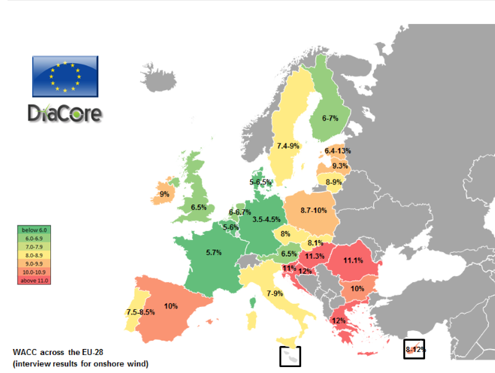

Eigenkapital-Kosten
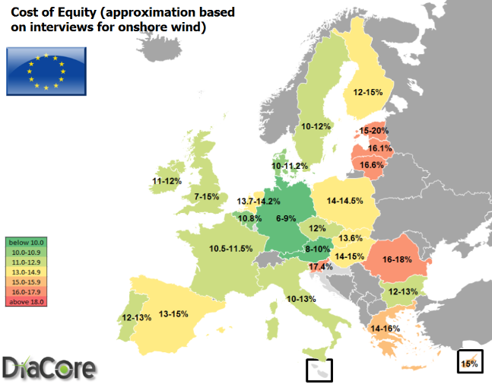

Kosten für Fremdkapital
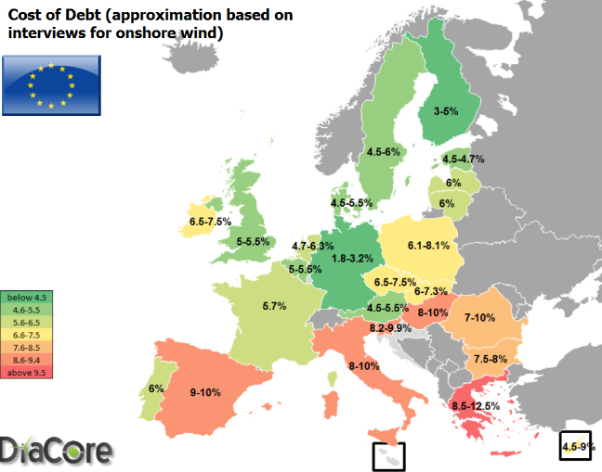

Verhältnis Fremdkapital zu Eigenkapital
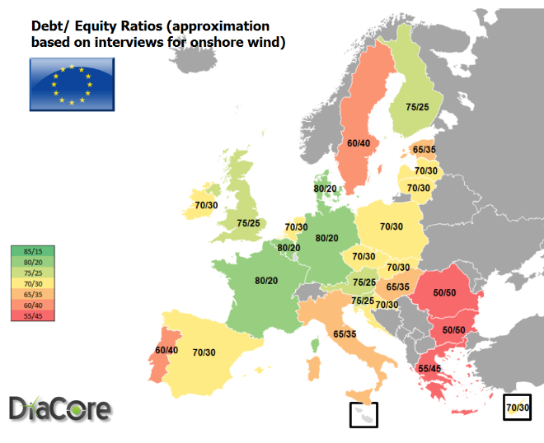

Introduction
As part of WP3 “Enhancing RES investments” the country risk profiles for the EU-28 member states were constructed. The results are disseminated via this website.
The risk profiles consist of nine risk categories that can influence RE investments in the member states. For each member state, the impact of these risk categories is estimated based on financial models, scientific literature and previous studies. After constructing the risk profiles, these were evaluated during interviews with bankers, equity providers and project developers. Almost 80 interviews have been conducted, covering 26 EU member states . Based on these interviews, the country risk profiles were completed.
Besides testing the risk profiles, the interviews were also used to test financial parameters such as cost of equity, cost of debt, WACC and debt/equity ratio that were used as input in the model. These parameters give useful insights in the investment climate in the different member states. To enable comparison between member states, these figures are combined in maps and graphs below.
Via the clickable map at the bottom of the website, risk profiles of individual member states are made available.

Short description of maps
Figure 1: WACC – interview results
This figure shows the WACC values according to interviewed experts. The WACC values are presented in ranges.
Figure 2. Cost of Equity - interview results
This figure presents the Cost of Equity values according to interviewed experts. The Cost of Equity values are presented in ranges.
Figure 3. Cost of Debt - interview results
This figure presents the Cost of Debt values according to interviewed experts. The Cost of Debt values are presented in ranges.
Figure 4: Debt/Equity ratio
This figure presents the Debt/Equity ratio values according to interviewed experts. The Debt/Equity ratio values are presented in ranges.
This figure presents how the Debt/Equity ratio of investments changes per member state. High shares of debt indicate that banks are willing to invest in these projects, giving project developers access to relatively cheaper capital.

