Frome Twinning Association
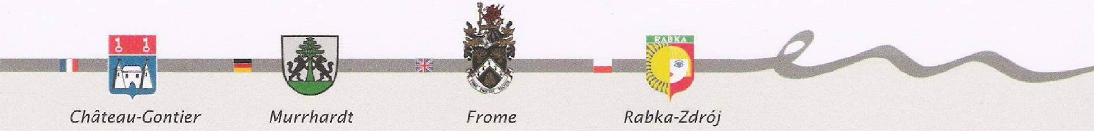

NEWSLETTER SEPTEMBER 2015

URGENT!
Murrhardt 8-11 October

There are still some places left for this trip to Murrhardt for the Thematic Networking Project weekend. Those interested in going should contact Damon Hooton immediately on 07850 681163 or damonhooton@yahoo.co.uk

Following a successful Stage 1 in Château-Gontier, the theme for this Stage 2 is "Citizens living and working within the EU." This is aimed at producing a working framework by which employers, employees, apprentices etc can work within their
own towns, as well as within the EU, with the opportunity for partnerships between employers etc in the four towns working with each other to achieve this. There will also be trips to visit local companies and the Mercedes and Porche museums in Stuttgart. The group will include young entrepreneurs from Frome College, plus representatives from the town council and local businesses, who will all give presentations on such things in Frome. Travel by air is being booked, and fares will be partially funded through an EU grant.

Stage 3, Frome, 4-7 March 2016
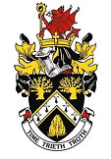
"Alternative Energy". This event is being organised and run by FTA and FTC with support from other organisations. Further details of the actual programme of events for this conference will be issued much nearer the time, but all are welcome to attend.
The organisers are looking for people to possibly host overseas guests who wish to attend this conference, and it would be appreciated if you would help out. Unlike Quadripartite events, those who host will be given a small allowance to offset their costs, exact details to be given when it is know how many hosts come forward. This method is preferable rather than hotels for several reasons, it's more friendly and, to be perfectly honest, cheaper, as the budget for the event is limited. Please contact Damon Hooton, as soon as possible, on 07850 681163 or damonhooton@yahoo.co.uk if you would be willing to help out.

Quadripartite Murrhardt, 21-24 July 2016
50th | This will also celebrate the 50th Anniversary of their twinning with Château-Gontier. We have been granted 30 places, to include some young people, so it will be a case of first come, first served. To book a place, contact Alan Glover as soon as possible on 01373 454576 or atg1949@hotmail.com | 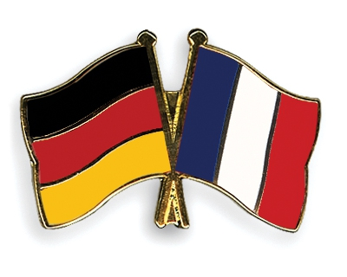

(cont’d over)

Plus . . .

Get-together
Beckington Village Hall
Saturday 3 October
7.15 for 7.45pm
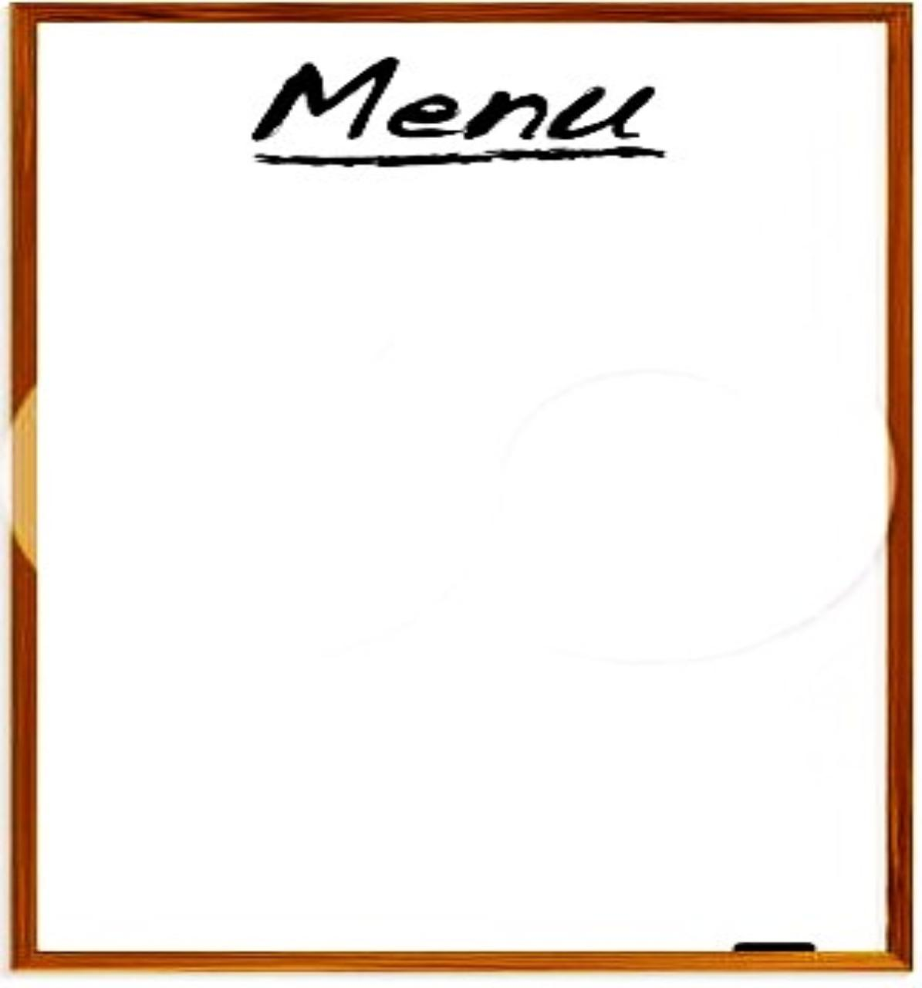

Chicken Casserole with
peas, carrots & potato

or Vegetable Pastie
+
Dessert

Tickets £12.50

Please note that we will not be running a bar, therefore
diners are asked to bring their own favourite drink.
There will be a raffle. Any offers of prizes would be welcome.

Come along and enjoy a friendly evening sharing photos of the recent visit.

To book a place, contact Alan Glover on 01373 454576 or atg1949@hotmail.com

. . . and finally . . .

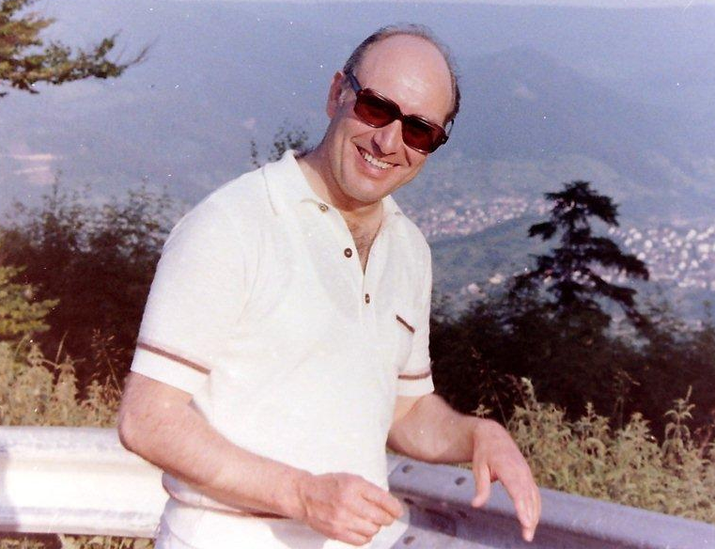  ! | Fritz Fegert  Sadly we have to report the death on 27 July of Fritz from Murrhardt. Older members will remember Fritz, of Autohaus Fegert, with his wife Waltraud who died in 2006, being very supportive in the early days of twinning with Murrhart.  Champagne over ice-cream on their balcony is a lovely memory for some of us, though the business was being robbed as we sat there!

Chairman: Alan Glover, 87 Selwood Road, Frome, BA11 3BP : tel 01373 454576
Secretary: Pat Boyd, 103 Leys Lane, Frome, BA11 2JS : tel 01373 474878
www.frometwinning.co.uk

