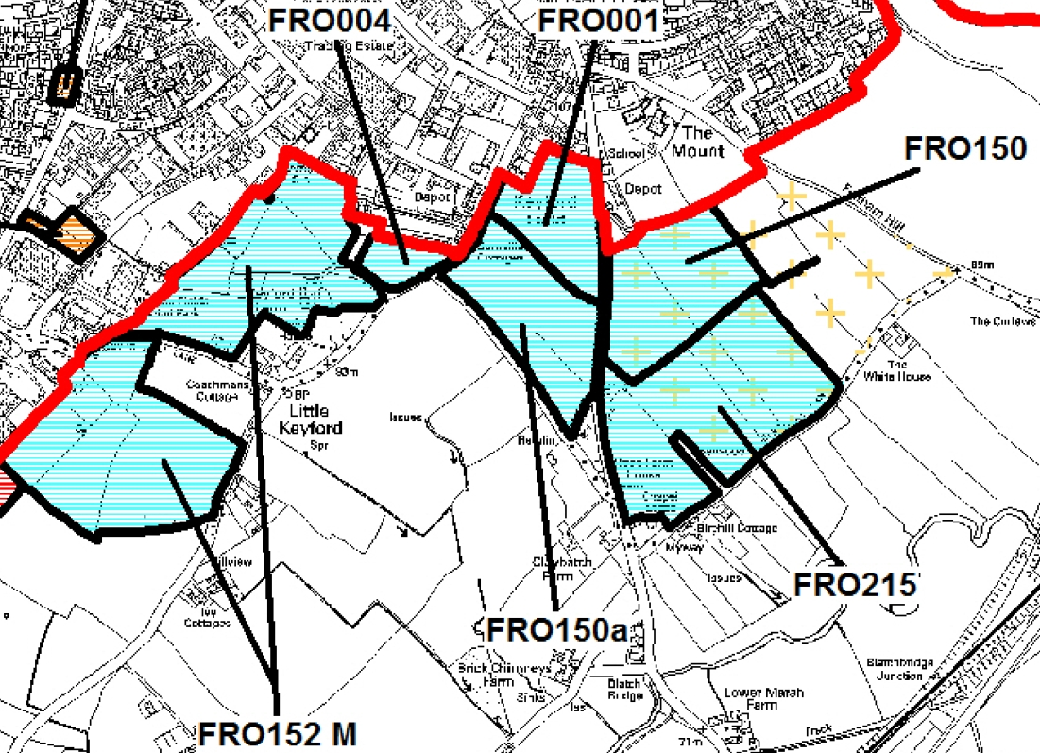
Site  Reference  Number | Size  of site  (ha) | Key site characteristics | Constraints and  Considerations | Initial  Assessment | Potential  Development  Option
FRO001  Keyford  Field, Little Keyford Lane | 2.4 | Fields along Little Keyford Lane. Currently outside the Development Limit but adjacent to existing housing.  Adjoins the Hardings Depot and Marston Trading Estate. | • Grade 3a  Agricultural  Land.  • Impact of adjacent noise  generating uses  • Impact on existing adjacent employment activities. | Potentially suitable for development although the impact of and from adjacent uses will need to be considered, as well as the loss of agricultural land. | Yes
FRO004  Little Keyford | 0.73 | Field adjoining the development limit on the southern edge of Frome. Some residential properties directly to the north and to the south west. Fields to the south. | • The trees along the frontage  are covered by a TPO  • Potential landscape  impact | Potentially suitable for development although consideration of the sites landscape impact will be needed as well as the protection of the significant trees. | Yes
FRO150  Land south of The Mount, Frome | 3.97 | Greenfield site currently in agricultural use. | • Promoted land lies within the designated Future Growth Area for Frome.  • Potential landscape impact | Site has been subject to consultation and consideration during the Local Plan Part I process and has been identified as a Future Growth Area for Frome although consideration of its impact of the landscape will be needed. | Yes– identified  as a Future  Growth Area
FRO150a  Land east of The Mount, Frome | 3.65 | Large field lying  between Little Keyford Lane and the B3092  The site slopes gently away in a south westerly direction and enjoys some screening from a number of lower mature hedgerows. | • Potential landscape Impact  • Highways access | Potentially suitable for development although the impact on the landscape will need careful consideration. | Yes
FRO152M  Land to north and south of Sandys Hill  Promoted for Housing and Employment Use | 12.4 | Agricultural land adjoining the Marston Estate and promoted for housing and extension to Industrial Estate (retail and employment units). Principal access would be via the Sainsburys roundabout. | • Landscape  Impact  • Impact on existing adjacent employment activities.  • Highways | Potentially suitable for development, although consideration of the impacts upon or from neighbouring uses will need to be considered. | Yes
FRO215  Land north of Birchill Lane | 6.8 | Extensive area of greenfield land lying to the south of the Mount bounded to the south by Birchill Lane.  The land slopes consistently downwards in a southerly direction and is subdivided by hedgerows. | • Potential landscape Impact  • Part of this site has been identified in Local Plan Part  I as a Future  Growth Area. | Potentially suitable for development although the impact on the landscape will need careful consideration. | Yes

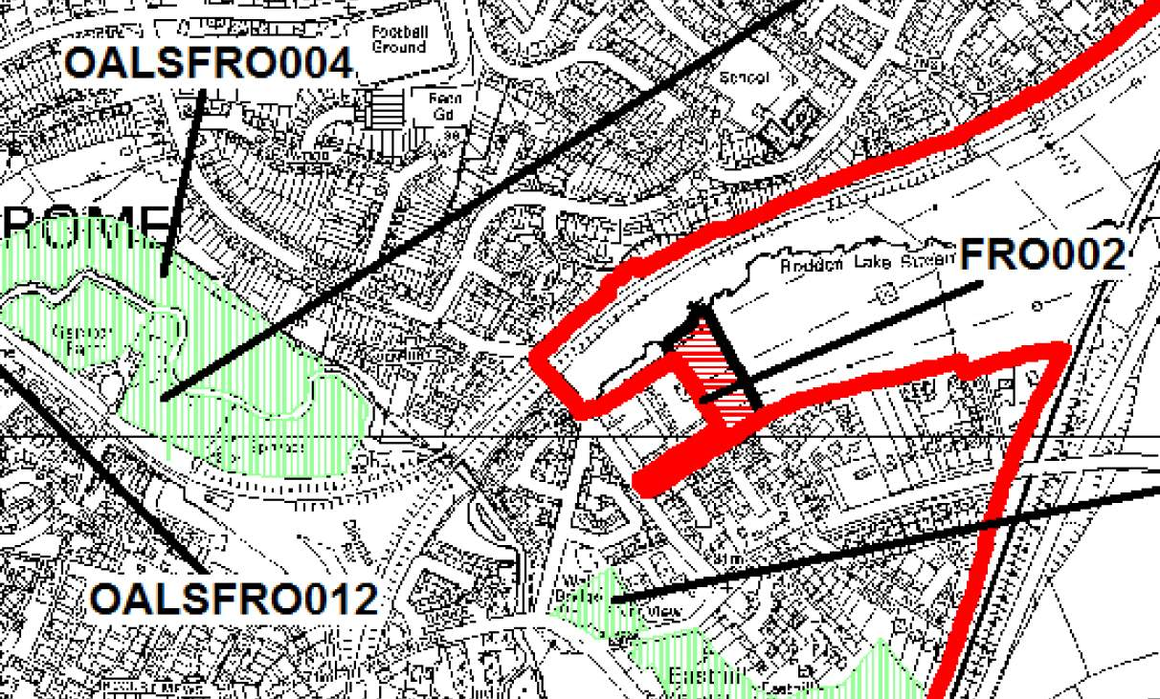

Site  Reference  Number | Size  of site  (ha) | Key site characteristics | Constraints and  Considerations | Initial  Assessment | Potential  Development  Option
FRO002  Land at  Rodden | 0.9 | L-Shaped field which slopes down from the south to Rodden Lake. Stream runs along the northern edge. Field access from Rodden Road to the west. Electricity power stations lie immediately to the west. | • Proximity to the railway line beyond.  • Overhead power cables extend across the site from west to east. | This site could potentially be suitable for development, but the costs of undergrounding the high voltage power lines mean this site is very unlikely to be a viable option and has been excluded as a possible option as a result. | No

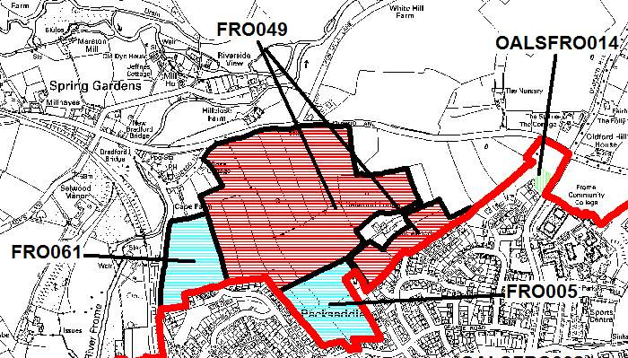

Site  Reference  Number | Size  of site  (ha) | Key site characteristics | Constraints and  Considerations | Initial  Assessment | Potential  Development  Option
FRO005  Land at  Packsaddle | 3.35 | 4 parcels of  grazing/agricultural land between Packsaddle and Leys Lane  The site slopes downwards into the river valley. | • Landscape impact  • Rights of Way  • TPO trees  • Land owned by SCC for education (school site) | While this site is potentially suitable its availability is dependent on clarifying reviewing future school development and capacity. | Yes
FRO061  Land at Innox Hill , off Packsaddle Way | 2.98 | Agricultural land to the north of the Innox area of Frome and lies adjacent to the River Frome.  The site slopes downwards into the river valley and can be accessed from Packsaddle Way to the south. | • Potential landscape impact  • Site lies within sewage buffer zone | The site is potentially suitable for development although consideration will need to be given to the constraints identified. | Yes
FRO049  Land North of Packsaddle Way, Frome | 18.3 | Extensive area of agricultural land to north and south of Selwood Lodge. Land slopes away from the existing edge of the settlement and is highly visible in the landscape. | • Location rejected as  strategic growth option in Local Plan  Part 1 process due to landscape impact on the Frome River Valley.  • Rights of Way cross site (north to south)  • Local Wildlife site (Mells River) to north  • Infrastructure and highway  requirements  • Impact on setting of  Listed Building (Selwood Lodge) | While land south of Selwood Lodge could be potentially suitable (with access from Lily Batch), the whole promoted land is excluded as extensive built development would breach the ridgeline and have a significant impact on the setting of Frome. The larger site would create a strategic-scale extension to the north of Frome. | No

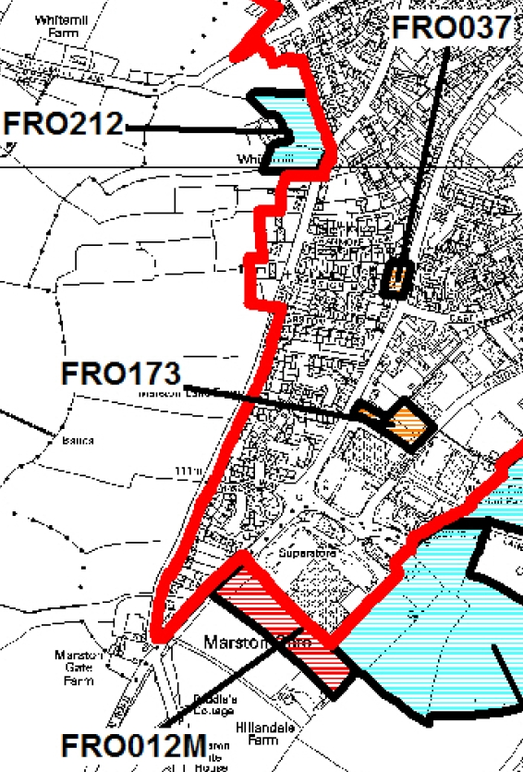

Site  Reference  Number | Size  of site  (ha) | Key site characteristics |  | Constraints and  Considerations | Initial  Assessment | Potential  Development  Option
FRO037  Land  adjacent to 2  Marston  Road, Frome | 0.17 | Small site adjacent to existing high density residential units. Located on very southern edge of the settlement. |  | • No significant constraints identified at this stage. | No significant constraints identified. Potentially suitable for development. | Yes
FRO173  Land Off Marston Road, Frome | 0.44 | Grazing field within the urban area on the main route in to Frome town centre. The site lies between retail warehousing and employment development and also adjoins sparse residential development to the north east and estate development to the north. Access currently achievable from Marston Road. |  | • Need to retain employment  land  • Impact from and upon adjacent employment and warehousing uses.  • Significant trees on Marston Lane frontage | Potentially suitable for development although the need for this site for employment uses will need to be considered as well as the constraints identified. | Yes
FRO012M  Land at Marston Gate, Frome | 1.46 |  | Greenfield site adjacent to Sainsburys with outline consent for business park. Being promoted for a pub/restaurant to front and residential behind. | • Potential landscape  Impact  • Loss of extant employment permission | Potentially suitable for development although the loss of this site from an extant employment permission will need to be considered.
FRO212  Land Off Marston Lane, Frome, BA11 1DG | 0.72 |  | Open agricultural land on the western edge of Frome with mature trees and hedgerows.  Site backs onto properties on Critchhill road and a large residential property (Whitemill) which could provide an access point. There is a bus stop at the southern end of Critchill Road. | • Extends into open land on the western fringe of Frome considered as important to the setting of the town. | Potentially suitable for development although careful consideration of the landscape impact will be needed. | Yes

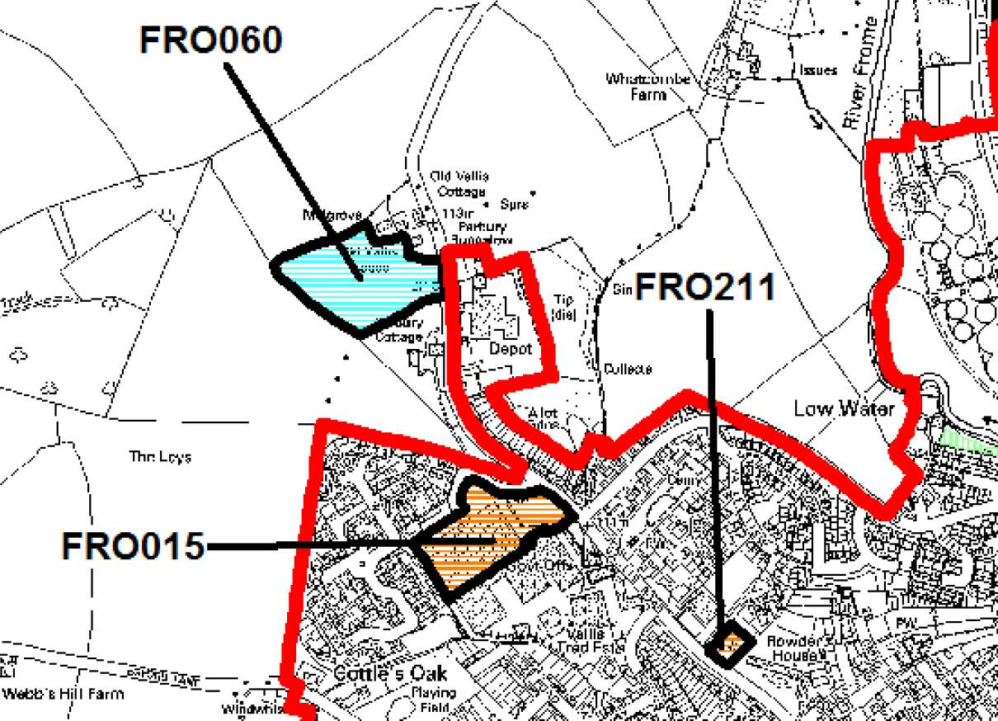
Site  Reference  Number | Size  of site  (ha) | Key site characteristics | Constraints and  Considerations | Initial  Assessment | Potential  Development  Option
FRO015  Land at the Vallis Trading Estate | 1.55 | Industrial space (now being cleared) on the former Weston Vinyls site. Lies adjacent to housing Wallingford Way and Vallis Trading Estate. | • Amenity considerations (adjacent employment)  • Need to retain employment land  • Potential contamination. | Potentially suitable for development although the need for this site for employment uses will need to be considered as well as the constraints identified. | Yes
FRO211  4 & 6 Vallis  Road, Frome | 0.15 | Slightly sloping.  Residential plot within the urban area fronting Vallis Road and Farrant Road. Potential access from Farrant Road. | • Bounded by the Frome  Conservation  Area.  • Protected trees on south eastern part of the site. | Potentially suitable for development although careful consideration of the site’s impact on the Conservation Area will be needed, as well as protection of the significant trees. | Yes
FRO060  Land to rear of Old Vallis House  Vallis Road | 2.0 | Agricultural land with access to Vallis Road.  Promoted as a self- build or co-ownership site. | • Potential Landscape Impact as site is visually prominent  • Groundwater Source Protection zone | The site is potentially suitable for development although consideration will be needed in relation to the landscape impact and other constraints identified. | Yes

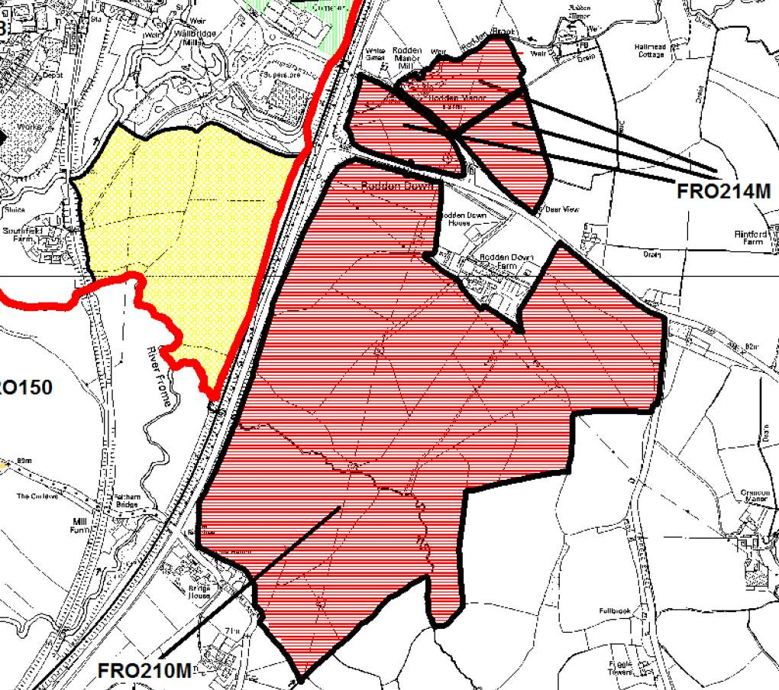

Site  Reference  Number | Size  of site  (ha) | Key site characteristics | Constraints and  Considerations | Initial  Assessment | Potential  Development  Option
FRO210M  Rodden Down Farm, Frome | 74.7 | Farm and associated land to the south east of Frome, on the eastern side on the A261 and bounded by the A362 on the south. | • Proximity to the Rodden  Valley Nature  Reserve  • Likely to be significant infrastructure costs to bring forward the whole area for development and to provide connectivity to the town centre.  • Landscape  Impact | This land is excluded as the general location beyond the Frome bypass is not considered to be well-related to the town. Any extensive development would have a significant impact on the setting of Frome and would create a strategic- scale urban extension. | No
FRO214M  Rodden Manor Farm, Frome | 11.04 | Collection of farm and mill buildings north of the A362 Warminster Road and surrounding agricultural land.  Three parcels of land have been promoted which have access to the A362.  Land is promoted for a ‘small business hub’ involving conversion of buildings at Rodden Manor Farm and development of open land to the south and southwest. | • Significant proportion of  the site is Flood Zone 2 or 3 along the Rodden Brook  • Landscape  Impact  • Power lines cross areas of the site  • Close proximity to the Rodden Valley Nature Reserve | The site is not considered suitable for development on the basis of landscape impact and flood risk. | No

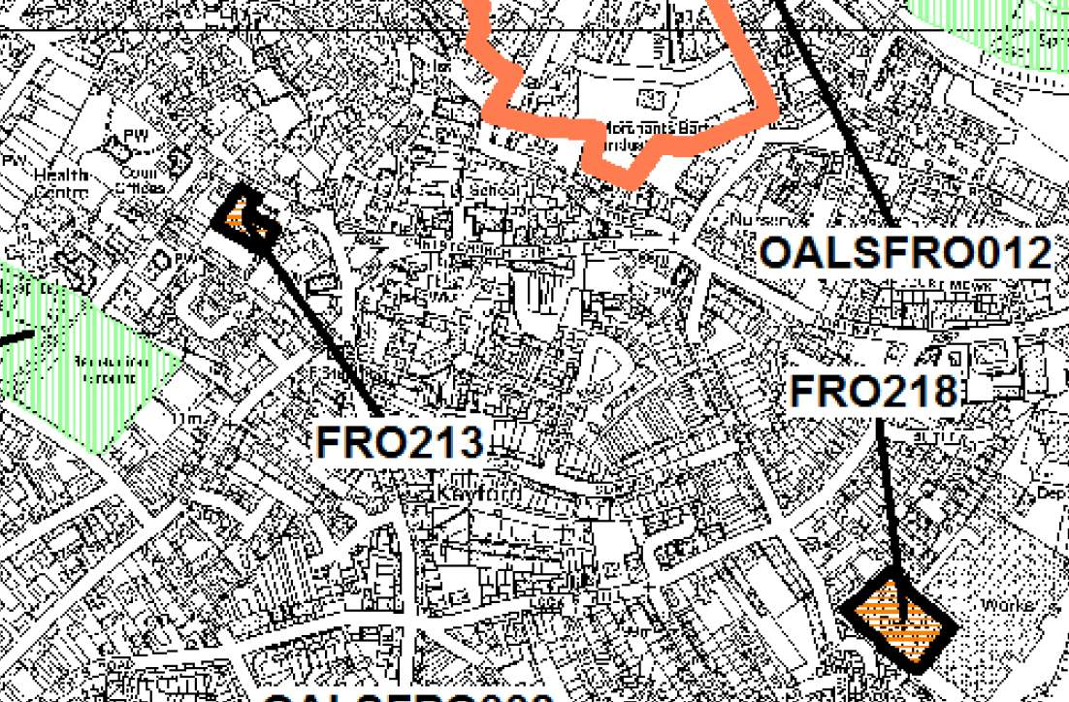

Site  Reference  Number | Size  of site  (ha) | Key site characteristics | Constraints and  Considerations | Initial  Assessment | Potential  Development  Option
FRO213  Braeside Works, Wesley  Close, Frome | 0.21 | Town centre factory premises adjacent to residential dwellings. | • Site adjoins  Conservation Area and listed building  • There are a number of trees covered by Tree Preservation  Orders.  • Access may be difficult on account of its town centre location.  • Current employment site – need for retention | Potentially  suitable for development although careful consideration of the site’s impact on the Conservation Area and listed building will be needed in any redevelopment, as well as protection of the significant trees.  Safe access to the site will also require consideration along with the need for the site to be retained for employment uses. | Yes
FRO218  Former Butler Tanner Depot  Land off  Adderwell | 0.6 | Cleared site of former depot. Lies adjacent to the Butler and Tanner Factory site for which resolution has been granted for mixed use development. Also surrounded by housing. | • Loss of employment  site | Potentially suitable for development although the loss of this site from employment use will need to be considered. | Yes

