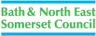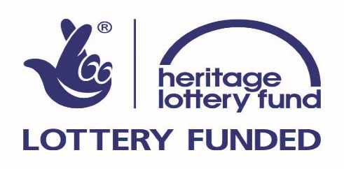

Heritage Is for Everyone – Heritage Lottery Fund Funding Information Event for Equalities Groups
13th November 10a.m. – 2p.m Guildhall, Bath.

Bath & North East Somerset Council are working with Heritage Lottery Fund (HLF) to host an HLF Information Event for equalities groups and organisations. HLF funds a wide range of projects from £3000 and upwards, that actively involve people in heritage. This can include, amongst other things: cultural traditions; histories of people, communities, places or events; languages and dialects; people’s memories and experiences.

HLF is keen to support the development of projects which achieve its outcomes for people, heritage and communities from groups working with people:

- with physical, sensory or learning disabilities or mental health issues
- from black, Asian and other minority ethnic groups, religious groups, Gypsies and Travellers
- from LGBT communities

This event will tell you more about HLF’s Sharing Heritage; First World War: then and now; Young Roots and Our Heritage funding programmes and some of the inspiring projects which equalities groups are running using HLF funding.

Angie McTiernan, a HLF Development Officer will unpack the HLF:

- Definition of heritage
- Application and assessment process
- Application dos and don’ts
- Project outcomes

There will be a practical exercise, an opportunity to ask questions, discuss potential projects and meet other groups.

Lunch will be provided. After lunch there will be:

- A limited number of 1:1 HLF surgeries for groups to discuss their specific heritage project. 1:1 surgery slots need to be booked in advance; please email Angela.McTiernan@hlf.org.uk by 30th October

To book your place at the event:
Email Sara_Banks@bathnes.gov.uk

Please let us know of any access or dietary requirements

