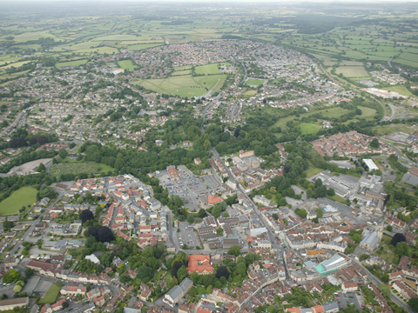 **Appendix vi**

**“YOUR TOWN”**

**“YOUR PLAN”**

**“YOUR FUTURE”**

**Public Consultation**

**28th October 2013 – 31st December 2013.**

**The Neighbourhood Plan has been developed to enable Frome to pursue a new approach to the development of the town over the next 20 years. It will enable the community of Frome to take greater control of the type and scale of development and land use. This is your chance to influence the plan.**

**HOW TO GET INVOLVED**

**The consultation draft can be viewed on our website** [**www.frome-tc.gov.uk**](http://www.frome-tc.gov.uk) **together with details on how to comment, or come along to one of our consultation events.**

**Drop in events**

**Sunday 3rd November – Frome Super Market, Unit 15 Westway Centre 10.00am – 2.00pm**

**Tuesday 5th November, Unit 15 Westway Centre – 10.00am – 4.00pm**

**Thursday 14th November - Oakfield Academy – 6.00pm – 9.00pm**

**Monday 18th November – Trinity Hall – 10.00am – 1.00pm**

**Wednesday 27th November – Selwood Academy – 6.00pm – 9.00pm**

**Friday 6th December 2013 – The Key Centre, 1.00pm – 4.00pm**



**‘Participate Frome’ - Frome Town Meeting**

**Wednesday 13th November – Cheese & Grain – 7.00pm – 9.00pm**

**There will also be information on display in Frome Library, from 28th October, through until 31st December 2013**

**For any enquires relating to the Neighbourhood Plan, please contact Jane Llewellyn 01373 465757 or email** [**llewellynj@frometowncouncil.gov.uk**](mailto:llewellynj@frometowncouncil.gov.uk)