RE: STRATEGIC ENVIRONMENTAL
ASSESSMENT AND HABITATS
REGULATIONS SCREENING REPORT

ON BEHALF OF: FROME TOWN COUNCIL

PREPARED BY: TETLOW KING PLANNING
UNIT 2, ECLIPSE OFFICE PARK,
HIGH STREET, STAPLE HILL,
BRISTOL BS16 5EL

TEL: 0117 956 1916
FAX: 0117 970 1293
EMAIL: all@tetlow-king.co.uk
WEBSITE: www.tetlow-king.co.uk

Constructionline Approved - Registered No: 8559

OUR REF: C:\M12\0805-11.RPT

DATE: AUGUST 2014

CONTENTS

Page

1. INTRODUCTION

2. LEGISLATIVE BACKGROUND

3. SCREENING FOR STRATEGIC ENVIRONMENTAL
ASSESSMENT 7

4. SCREENING FOR APPROPRIATE ASSESSMENT 15

5. CONCLUSIONS 21

APPENDICES

APPENDIX A: SOMERSET COUNTY COUNCIL HRA SCREENING REPORT EXTRACT

APPENDIX B: ASSESSMENT OF CONFORMITY WITH THE EMERGING LOCAL PLAN

APPENDIX C: POLICY-BY-POLICY ASSESSMENT OF SIGNIFICANT EFFECTS

APPENDIX D: OCTOBER 2013 CONSULTATION VERSION OF FROME NEIGHBOURHOOD DEVELOPMENT PLAN

Section 1

Introduction

- Frome Town Council has prepared the Frome Neighbourhood Development Plan (NDP). The Frome NDP will set out a series of policies to help achieve local community objectives for new development within the town. The Frome NDP must be in accordance with the strategic elements of the Mendip District Council Local Plan 2006-2028.

- A statutory consultation, in accordance with Regulation 14 of the Neighbourhood Planning Regulations 2012, took place between 28 October 2013 and 31 December 2013.

- This screens this plan and the proposed minor modifications published on June 2014.

- This Screening Report, following on from earlier such reports and work, has been undertaken to provide Mendip District Council with the necessary information to allow them to determine if the Draft Frome Neighbourhood Development Plan will require a full Strategic Environmental Assessment under the Environmental Assessment of Plans and Programmes Regulations 2004. The assessment is a requirement of European SEA Directive - 2001/42/EC(d) on the assessment of the effects of certain plans and programmes on the environment.

  - This Screening Report, and earlier work have influenced the content of the plan and as such will allow Frome Town Council and Mendip Council, to assess if an Appropriate Assessment is required of the Frome NDP under the Conservation of Habitats and Species Regulations 2010. The Regulations set out the detailed requirements for the EU Habitat Directives 92/43/EEC on the conservation of natural habitats and of wild flora and fauna (as last amended by Council Directive 97/62/EC(e)).

  - Mendip District Council are responsible for determining if the Frome NDP would have significant environmental effects according to specific criteria (2004 SEA Regs) or on a European site (Natural Habitats Regs 2010).

  - The Screening Report concludes that the plan will not have significant environmental effects when judged against the criteria of Schedule 1 of the 2004 SEA Regulations. Thus, a full Strategic Environmental Assessment would be required.

  - The Screening Report concludes that there are no likely significant effects on European sites and thus an Appropriate Assessment is not required.

  - The Frome NDP does not seek to change any emerging Local Plan policies. Where there is considered to be conflict between the proposed NDP policies and the emerging Local Plan policies these have been highlighted in the report.

  - Based on earlier work, assessing and influencing the emerging plan, changes have been made to policy wording throughout the formulation process to ensure accordance with the relevant regulations and the emerging Local Plan.

  - The Screening Report is based on the October 2013 consultation draft of the Frome NDP which is appended to this report and the Proposed Minor Modification. Should there be further amendments then these alterations should be subject to assessment scrutiny.

  - Reference has been made to a range of local and national information sources including the MAGIC website and the designations it contains, the AONB Management Plan, various landscape assessments conducted by Mendip District Council, the development plan and many other sources.

Section 2

Legislative Background

Strategic Environmental Assessment

2.1 The basis for Strategic Environmental Assessments and Sustainability Appraisal legislation is European Directive 2001/42/EC and was transposed into English law by the Environmental Assessment of Plans and Programmes Regulations 2004, or SEA Regulations. Detailed Guidance of these regulations can be found in the Government publication ‘A Practical Guide to the Strategic Environmental Assessment Directive’ (ODPM 2005).

2.2 The Planning and Compulsory Purchase Act 2004 required Local Authorities to produce Sustainability Appraisals (SA) for all local development documents to meet the requirements of the EU Directive on SEA. It is considered best practice to incorporate requirements of the SEA Directive into an SA, however there is no legal requirement for the Sustainability Appraisal of Neighbourhood Plans.

2.3 The SEA Regulations require the Responsible Authority, which in this instance would be Mendip District Council, to determine whether or not it considers the NDP likely to have significant environmental effects, taking into account the criteria for the likely significance of effects and consult Natural England, English Heritage and the Environment Agency (who for the purposes of SEA are known as the Consultation Bodies). It is advisable to seek a Screening Opinion from the Consultation Bodies using the findings of this Screening Report.

2.4 The Regulations require that the Responsible Authority determines whether or not they consider that the NDP will have significant environmental effects. In making their determination, the Responsible Authority must prepare a statement setting out its reasons for this.

2.5 Within 28 days of making a determination, the Responsible Authority must:

- Send each Consultation Body a copy of the determination and statement of its reasons for the determination
- Keep a copy of the determination and accompanying statement of its reasons for the determination at its principle office for inspection
- Take such steps as the Responsible Authority to consider appropriate to bring to the attention of the public:

- The title of the plan to which it relates
- That the Responsible Authority has determined that the NDP is or is not likely to have significant environmental effects and whether or not an SEA is required
- The address (and website) where copies of the determination and accompanying statement of reasons may be seen or a copy obtained.

2.6 Following determination, should the Responsible Authority consider that an SEA is required then they must consult with the Consultation Bodies to determine the scope and level of detail to include in the Environmental Report. The Consultation Bodies are required to respond within 5 weeks of the date on which they receive the Scoping Report.

2.7 The Responsible Authority must prepare an Environmental Report which identifies, describes and evaluates the likely significant effects on the environment of implementing the NDP and reasonable alternatives taking into account the objectives and scope of the NDP.

2.8 The Environmental Report must cover the topics and information set out in the Regulations taking account of current knowledge and methods of assessment, the content and level of detail in the NDP, the stages of the NDP in the decision-making process and the extent to which certain matters are more appropriately assessed at different stages in the process to avoid duplication.

2.9 Once the Environmental Report has been drafted then it must be consulted upon in conjunction with the NDP. When consulting upon this, in addition to the statutory requirements for the consultation of the NDP, the Responsible Authority must:

- Provide copies to the Consultation Bodies
- Take steps to bring the documents to the attention of people who the Responsible Body considers are affected by, are likely to be affected by or have an interest in, the decision involved in the Environmental Statement and adoption of the NDP
- Inform consultees where they may view the documents
- Invite the Consultation Bodies and public consultees to make representations
- Make copies available at the Responsible Bodies principal office

2.10 There is no specified timeframe for allowing representations, but it would seem sensible to allow the same period of time as the NDP consultation would be scheduled for.

  - Following adoption of the NDP, the Responsible Authority must:

- Make a copy of the NDP and SEA available at its principle office
- Take steps to publicise the title of the NDP, the date of adoption, where the NDP and SEA can be viewed and at what times
- Inform the Consultation Bodies, people who were public consultees and the Secretary of State
- Make available a statement which:

- Demonstrates how environmental considerations have been included in the NDP
- How the Environmental report has been taken into account
- How consultation responses have been taken into account
- The reasons for choosing the NDP as adopted instead of other reasonable alternatives
- Measures being taken to monitor significant environmental effects of the implementation of the NDP

2.12 The Responsible Authority must then monitor the significant environmental effects of the implementation of the NDP to identify unforeseen adverse effects as early as possible to take remedial action.

Habitats Regulations Assessment (Appropriate Assessment)
2.13 Under Article 6 of the European Habitats Directive, Appropriate Assessment (AA) is required where a plan or project may give rise to significant effects upon a European (Natura 2000) site, which include Special Areas of Conservation (SACs, designated under the Habitats Directive) and Special Protection Areas (SPAs, designated under the Birds Directive, 79/409/EEC).
2.14 The Conservation of Habitats and Species Regulations 2010 (as amended) transpose the requirements of the Habitats Directive into national law. Regulation 61(1) stipulates that if a plan or project is likely to have a significant adverse impact on any Natura 2000 sites in the UK, the competent authority (in this case Mendip District Council) shall undertake AA of the implications for the site in view of its conservation objectives.
2.15 Part 5 of Regulation 61(1) states that:
“In light of the conclusions of the assessment, and subject to Regulation 62 (considerations of overriding public interest), the competent authority may agree to the plan or project only after having ascertained that it will not adversely affect the integrity of the European site or the European offshore marine site (as the case may be)”
2.16 In other words, if it can be demonstrated that significant adverse impacts on these sites are unlikely, no further assessment is required and the process poses no obstacle to planning permission being granted. Under Part 6, if likely significant adverse impacts or effects are identified, then a more detailed assessment is required of the effects of the proposal and what mitigation can be achieved through scheme redesign, planning contributions and/or conditions.
2.17 It is for the Council to decide how to fulfil this legal obligation though it will certainly produce a report setting out the AA process and its own conclusions. It falls on the applicant to provide the Council with sufficient information. This report and its findings are considered to contain the appropriate level of information to satisfy the regulations.

Section 3

Screening for Strategic Environmental Assessment

3.1 The Frome NDP meets the definitions within the SEA Directive of a Plan that is subject to the Directive. Under Article 2(a), the plans and programmes subject to the SEA Directive are those which are:

- Subject to preparation and/or adoption by an authority at national, regional or local level or which are prepared by an authority for adoption through a legislative procedure by Parliament or Government, and
- Required by legislative, regulatory or administrative provisions

3.2 The second bullet point above has been interpreted by a March 2012 European Court Ruling as being intended to apply to plans and programmes, which are provided for by national legislation but whose adoption by the competent authority would not be compulsory. This means that NDPs England would meet the Article 2(a) requirements.

3.3 It is considered that the Frome NDP would also meet the requirements in Article 3(2) of the SEA Directive, which makes SEA mandatory for plans and programmes:

- Which are prepared for agriculture, forestry, fisheries, energy, industry, transport, waste management, water management, telecommunications, tourism, town and country planning or land use and which set the framework for future development consent for projects listed in Annexes I and II to the Environmental Impact Assessment (EIA) Directive (85/337/EEC)
- Which, in view of the likely effect on sites, have been determined to require an assessment pursuant to Article 6 or 7 of the Habitats Directive (92/43/EEC)

3.4 The ODPM SEA Guidance (2005) refers to the European Commission guidance on SEA which explains that plans and programme ‘which set the framework for future development consent of projects’ would normally contain ‘criteria or conditions which guide the way a consenting authority decides an application for development consent’. Therefore, as the Frome NDP would be used by Mendip District Council to guide the determination of planning applications for development with the Frome Neighbourhood Plan area, then it would also meet the requirements of Article 3(2) of the SEA Directive, and should be subject to SEA.

3.5 The European Commission guidance suggests that plans and programmes which are prepared for town and country planning or land use “deal with the way land is to be developed or redeveloped. These terms may be used in different ways by different member states, but generally both deals with the way territory is to be used, even if one may comprise a broader concept than the other.”

3.6 Therefore it is considered that the Frome NDP falls into this category of plan, i.e. one which deals with the way land is to be developed or redeveloped. This means that under Article 3(5) of the SEA Directive, a Screening exercise needs to be undertaken by the Responsible Authority to determine if the NDP is likely to have significant environmental effects, and hence whether a full SEA is required.

3.7 Schedule 1 of the UK SEA Regulations 2004 lists criteria for determining the likely significance of the environmental effects of plans and programmes as set out below:

- The characteristics of plan and programmes, having regard, in particular, to
- The degree to which the plan or programme sets a framework for projects and other activities, either with regard to the location, nature, size and operating conditions or by allocating resources
- The degree to which the plan or programme influences other plans and programmes including those within a hierarchy
- The relevance of the plan or programme for the integration of environmental considerations in particular with a view to promoting sustainable development
- Environmental problems relevant to the plan or programme
- The relevance of the plan or programme for the implementation of Community Legislation on the environment (e.g. plans and programmes linked to waste management or water protection)

- Characteristics of the effects and of the area likely to be affected, having regard, in particular, to
- The probability, duration, frequency and reversibility of the effects
- The cumulative nature of the effects
- The transboundary nature of the effects
- The risks to human health or the environment (e.g. due to accidents)
- The magnitude and spatial extent of the effects (geographical area and size of the population likely to be affected)
- The value and vulnerability of the area likely to be affected due to:
  - Special natural characteristics or cultural heritage
  - Exceeded environmental quality standards or limit values
  - Intensive land-use
  - The effects on areas or landscape which have a recognised national, Community or international status.

3.8 The criteria listed in Schedule 1 of the SEA Regulations have been used to complete the screening assessment. Appendix C provides an assessment of the policies of the NDP against each of the criteria for determining the likely significance of effects. An overall conclusion has been made as to whether the NDP is likely to result in significant environmental effects, and therefore require a full SEA assessment.

Purpose and Structure of the NDP

3.9 The Frome NDP has a particular focus on:

- Encouraging small businesses to start and grow
- Enabling people to build their own homes, live more affordably in a more energy efficient way and play a more active part in the community
- Making it easier for people to get around the town on foot and by bicycle
- Regenerating the town centre so that it functions better as a place to live, work meet, shop and visit
- Making the most of the River Frome corridor as an environmental and recreational asset
- Ensuring future development does not damage Frome’s unique character

3.10 There are three overriding themes which frame the policies of the NDP:

- VCO1 – Vitality - To recognise that land and buildings provide the
supporting infrastructure within which a range of interconnected activities take place: work, play, eating, sleeping, shopping, socialising, etc.

- VCO2 – Sustainability - To provide the framework for a town-wide transition to a low carbon economy.
- VCO3 – Participation To respect the underlying principle that the community has the right to participate in the process of development.

3.11 The NDP will be subject to examination and referendum and then form part of the Local Development Plan. This statutory status gives NDPs far more weight than some other local planning documents such as Parish Plans, Community Plans and Village Design Statements. It will be a material consideration in the determination of future development proposals in Frome and will support the core policies of the emerging Mendip District Local Plan, particularly:

- Core Policy 1: The majority of development will be directed towards the five principal settlements of Frome, Glastonbury, Shepton Mallet, Street and Wells to reinforce their roles as market towns serving their wider rural catchments.
- Core Policy 2: Provision for a minimum of 9,635 additional dwellings in Mendip with Frome having a 25% share of this (2,300).
- Core Policy 3: sets out the employment land requirements over the plan period.
- Core Policy 5: encourages community leadership and local community based plans.
- Core Policy 6: sets out the overarching strategy for the future growth of Frome.

3.12 A number of Local Development Policies are also set out in the emerging Local Plan which are grouped into specific themes aimed at ensuring that the natural, cultural and built assets of the district are safeguarded, whilst seeking to ensure development is of a high quality having regard to setting and design quality.

3.13 The NDP identifies appropriate forms of development which will be encouraged in Frome, and provides guidance to help make such proposals acceptable to the community. It has been prepared for

- Planning Officers and Elected Members – to provide a consistent framework for determining applications within Frome
- Developers – to provide guidance on the key issues for consideration in Frome and how potential impacts could be minimised
- Members of the Public – who have an interest in development proposals in Frome

3.14 The NDP contains nine chapters and is structured as follows:

- Chapter 1 – Foreword: outlines the purpose and focus of the NDP.
- Chapter 2 – The Planning Framework: sets out planning policy context for developing the Neighbourhood Plan.
- Chapter 3 – Vision and Core Objectives: outlines three golden threads framing the policies of the NDP.
- Chapter 4 – Housing: sets out the housing policies to encourage sustainable growth in Frome.
- Chapter 5 – Business and Employment: provides policies to support for new and existing businesses.
- Chapter 6 – The Town Centres: identifies three town centre zones and policies to support the development of these areas.
- Chapter 7 – River Corridor and Public Open Space: provides policies to support improved access and opening up of the river corridor.
- Chapter 8 – Transport: outlines improvements to deliver integrated transport options.
- Chapter 9 – Design: sets out the key design requirements for development proposals.

Screening

3.15 None of the policies of the NDP seek to allocate specific sites which are not already subject to policy requirements within the emerging Local Plan, they instead attempt to add a local dimension to the Local Plan policies. For example policies affecting major development do not allocate these sites, but merely seek to influence design, the mix of uses and add local criteria to help achieve the overriding themes of the NDP. This limits the likelihood of the effects of such policies being considered ‘significant’.

3.16 The assessment in Appendix C to this report concludes that none of the proposed policies of the NDP, now subject to amendment following the consultation at the end of 2013, have the potential for significant environmental effects to occur. It useful to examine below however those policies that have been most influenced by the ongoing assessment work.

Policy H6: Community Housing

- The policy makes provision for allowing self build and community housing development outside and adjoining the settlement boundary subject to certain requirements.

- Important to this screening is that one criteria is that such proposals should not have an adverse or harmful impact on statutorily protected species or habitats. This criteria will not allow development with the potential to impact on protected species or habitats to be refused should that impact be harmful. This will protect the important areas to the north and west of the town that are close to the Mells Valley Special Area of Conservation’s Ecological Zone of Influence related to bat habitat. There is the Vallis vale Site of Special Scientific Interest to the west of Frome but again the criteria of the policy would prevent development that either on its own of cumulatively woud impact on that area or any zone of influence. Information on the Mells Valley SAC and its ecological influence zones is included at appendix A.

- There are also landscape impact issues. Frome sits outside and almost equidistant between the Mendip Hills AONB to the west and North Wessex Downs AONB to the east. The Cranborne Chase and West Wiltshire Downs AONB site to the south and east. It is difficult to see why this policy would impact the reasons why the AONB areas were designated.

- Figure 1 below demonstrates that a significant proportion of the land outside of the settlement boundary to the north and western fringe of Frome is identified as being “good quality land which is prominent and important in the setting of the town”. To the south and east of the settlement boundary there are pockets of land which fall into this category but also land with the category of “good quality landscape which is visually related to the town but less important to its setting”. The majority of the land to the south and east is identified as being “good quality land not visually related to the town or which forms a distant backdrop”.

Figure 1: Frome Landscape Characteristics

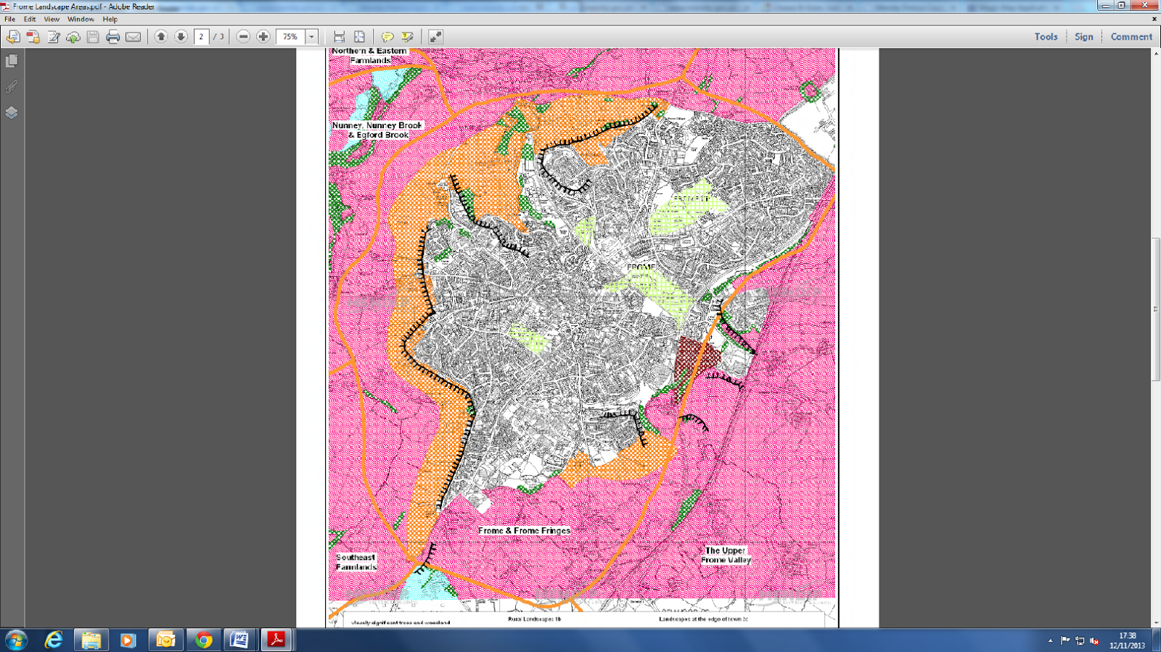
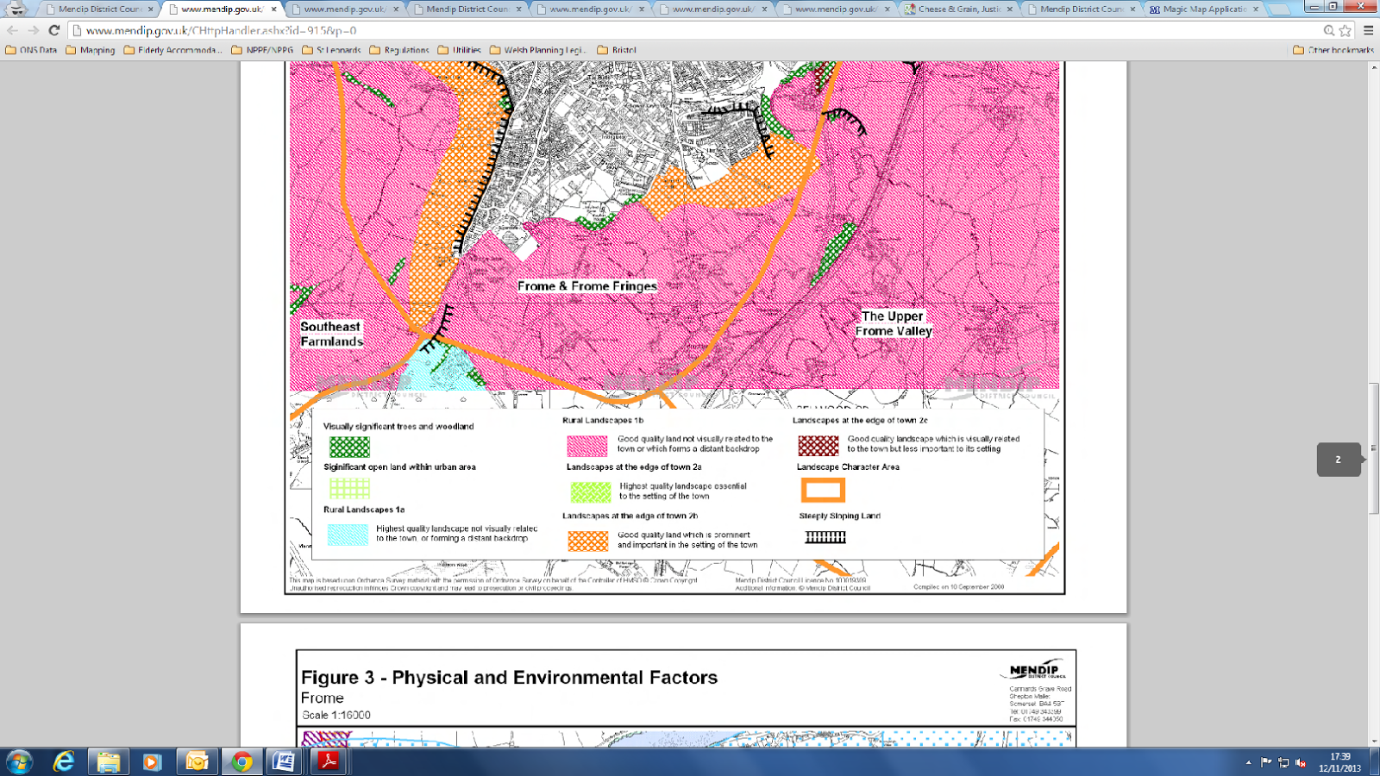

- The policy does not allocate sites nor does it indicate directions of growth where such development outside of the settlement boundary may be acceptable and as a result, subject to the final siting of sites proposed under this policy, there is the potential for significant environmental impacts to occur, particularly to the north and west of the town. However the policy states that any development “..will not have an significant adverse impact on the character of the area and local landscape setting”. With this criteria we do not see that the development will have significant impacts on landscape character and setting.

- The emerging Local Plan seeks to ensure that development is contained within the defined development boundary of settlements. In exceptional circumstances where development is proposed outside of these defined boundaries, it would only be permitted where it benefits economic activity or extends the range of facilities available to local communities. This is a potential conflict with the Mendip Local Plan in terms of single developments or from a cumulative effect. However the actual latest wording of the Local Plan is (6.134):

“In identifying land for development the Local Plan’s emphasis is on maximising the re-use of appropriate previously developed sites and other land within existing settlement limits as defined on the Policies Map, and then at the most sustainable locations on the edge of the identified settlements”.

- The latest version of the plan says that the Government is currently intending to consult on options for increasing the supply of housing through self build schemes but that in the mealtime:

“..the Council will support the construction of self build schemes where appropriate and will keep under review how to provide appropriate support for such development”.

The NDP is also seeking to increase the supply of self build schemes, as per this Local Plan, comment through works within the settlement limits but also in a limited and very controlled way outside. The supply inside the settlement limits will not meet the demand. This was clear from community feedback and consultation.

- The NDP identified self build and community housing to be a significant issue in the town with the clearly identified issue that the supply of land was the issue i.e. opportunity. This policy looks at land adjoining one of the most sustainable settlements in the Local Plan area. Thus it will only be land that is at the most sustainable locations because it will be adjoin the existing limits of Frome. Given the statement in the emerging plan that the Council will support “the construction of self build schemes” combined with the lack of supply in the town it is considered that there is no conflict with the emerging Local Plan. This can also be combined with paragraph 50 of the National Planning Policy Framework where it says local planning authorities should plan for a mix of housing based on current and future demographic trends, market trends and the needs of different groups in the community which includes “people wishing to build their own homes”.

Policy T1: Integrated Transport Strategy

- The policy seeks to promote the delivery of a range of integrated sustainable transport options which includes completing Frome’s ‘Missing Links’ in the National Cycle Network. The emerging Local Plan HRA Screening Report states that the completion of the Frome ‘Missing Link’ could have a detrimental impact on foraging areas for bats from the Mells Valley SAC if it were to introduce any new hedgerow gaps of more than 15 metres. It should be noted that detrimental impacts are not anticipated to the SAC itself.

- The policy was considered to have the potential for significant impacts in relation to the requirements of the SEA as it could adversely impact upon the foraging areas for bats within the Mells Valley EZI however the policy wording has now been amended to prevent impacts on the Mells Valley EZI.

Policy TC1: Town Centre Remodelling

- The policy seeks to encourage highway and public realm improvements within the town centre. Traffic modelling work by Somerset County Council has found that the proposal would result in a reduction in vehicle speeds through the town centre from an average of 15 mph to 11 mph as a result of increased decelerating and accelerating on the approach and exit to the remodelled area. This may bring about further emissions in an area of the town where air quality is already poor and therefore have a detrimental impact on air quality which conflicts with the policy requirement that proposals must be proven to cause no deterioration in air quality.

- The policy was considered to have the potential for significant impacts in relation to the requirements of SEA as the reduction in vehicle speeds and resultant increase in decelerating and accelerating may have brought about further emissions in an area of the town where air quality is already poor however a criteria has been added that any such remodelling would have to ensure that it would cause no deterioration in air quality.

Section 4

Screening for Appropriate Assessment

  - The first step of the screening report for an Appropriate Assessment is to identify any European sites that might potentially be affected by the policies within the Frome NDP.

  - The Screening Report in to the Mendip District Council’s Draft Core Strategy is the starting point for this. Somerset County Council produced the report for the District Council in 2011 and they listed the potentially affected SACs and SPAs as:

- Mendip Limestone Grasslands SAC
- Chew Valley Lake SPA
- River Avon SAC
- Bath and Bradford on Avon Bats SAC
- Salisbury Plain SAC
- Mells Valley SAC
- Mendip Woodlands SAC
- North Somerset and Mendip Bats SAC

  - The Somerset County Council (SCC) Screening Report concludes that the Mendip Limestone Grasslands SAC, River Avon SAC and the Salisbury Plain SAC are not affected by policies within the Core Strategy. It is considered that the policies within the Frome NDP would not affect these areas for the same reasons.

  - Of the remaining areas only the Ecological Zone of Influence (EZI) of the Mells Valley SAC abuts the edge of the built up area of Frome. The Bath and Bradford Bats SAC EZI is within relatively close proximity, but the Bath and Bradford SAC EZI is focussed around the edge of Radstock. This shown in the figures below. The Mendip Woodlands SAC is sensitive to dust and air pollution, but it is not considered that the SAC is sufficiently close to Frome to be affected by development within Frome of the type envisaged by the NDP.

Figure 3: Bath and Bradford on Avon Bats: Ecological Zone of Influence in Mendip

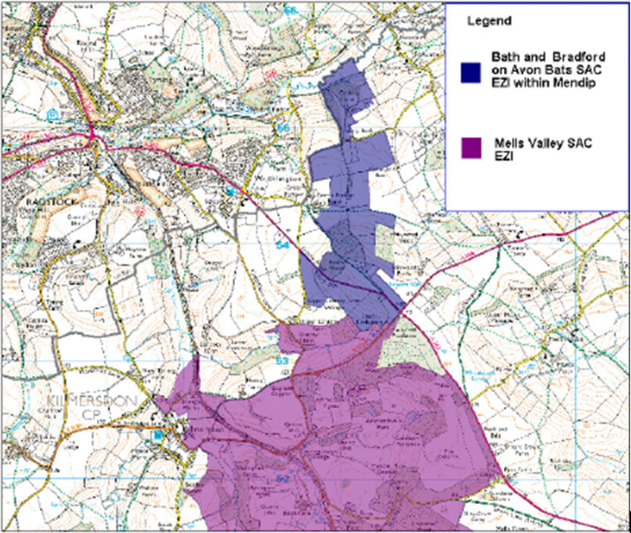

Source: Somerset County Council 2011 Core Strategy HRA Screening Report

Map 4: Mells Valley SAC Ecological Zone of Influence

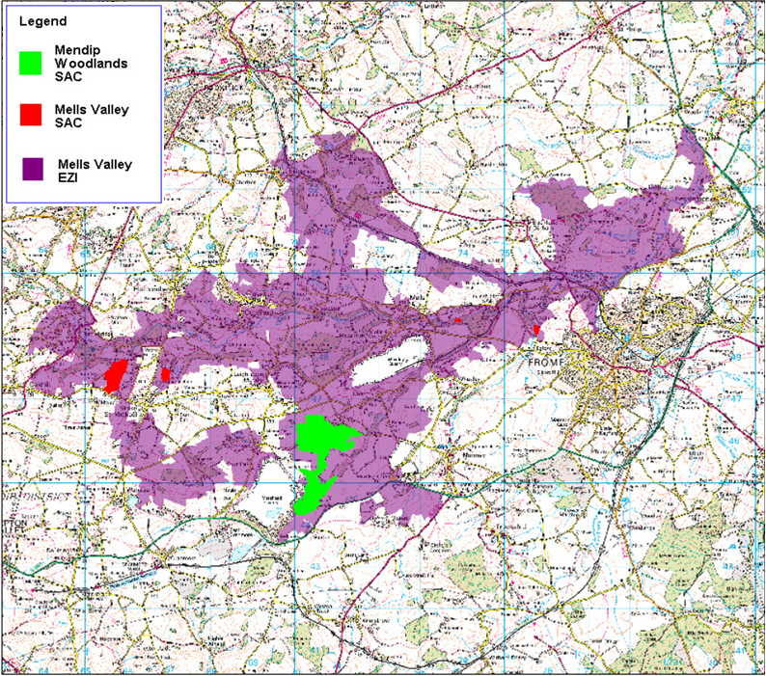
Source: Somerset County Council 2011 Core Strategy HRA Screening Report

Map 5: North Somerset and Mendip Bat SAC Ecological Zone of Influence

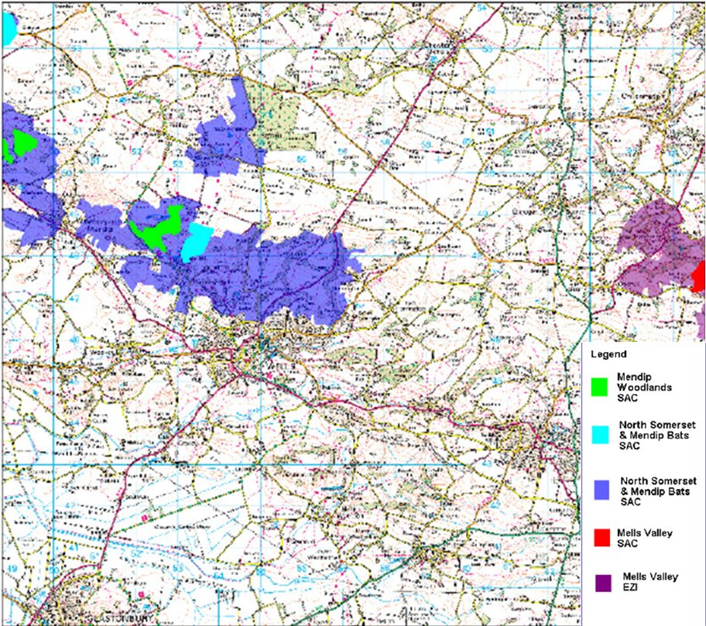
Source: Somerset County Council 2011 Core Strategy HRA Screening Report

Mells Valley SAC

  - After consultation with the Somerset CC Ecology Officer it was agreed that the Mells Valley SAC was the only SAC or SPA that could potentially be affected by development brought forward by the Frome NDP. The Mells Valley EZI stretches across the north and west edge of the town. It is therefore considered that the SAC could potentially be affected by development arising from policies within the NDP. It is designated on the basis of the size of its exceptional breeding population of Greater Horseshoe Bat, which is a protected species. It contains the maternity site associated with a population comprising about 12% of the UK population. A large proportion of the population also hibernates on-site.

  - The bats forage for food in areas outside of the SAC, these are shown on the EZI map above.

  - The SCC Screening Report sets out the “current factors considered to be causing loss or decline in greater horseshoe bats” these are listed as:

- Loss, destruction or disturbance of roost sites.
- Loss, damage or fragmentation of important foraging habitats and flyways, such as woodland, and connecting linear features such as hedgerows and tree lines and pasture.
- Lack of suitably connected foraging habitats (a mosaic of pasture hedgerows and woodland)
- Loss or disruption of key flyways between different roosts

  - The conservation objectives for the Mells Valley SAC are also listed in the SCC Screening Report, these are listed as:

- “To maintain, in favourable condition, the habitats for the population of Greater horseshoe bat
- To maintain, in favourable condition, the caves not open to the public
- To maintain, in favourable condition, the semi-natural dry grasslands and scrubland facies: on calcareous substrates (Festuco-Brometalia)”

  - The SCC Screening Report also sets out the Key Environmental Conditions for the SAC. These are show in Table 1.

Table 1: Mells Valley Key Environmental Conditions

Qualifying features | Key environmental conditions to support site integrity
Greater horseshoe bat | Undisturbed roosts  Roost conditions maintained  Appropriate management of vegetation at roost entrances  Maintenance and connectivity of habitats used as flight line on and off site  Feeding areas
Caves not open to the public | Pressure from human activity above and below ground  Management of overlying land and catchment
Semi-natural dry grasslands and scrubland facies on calcareous substrates | Appropriate management  Soil conditions  Sward structure and composition  Absence of negative indicator species
Source: Somerset County Council 2011 Core Strategy HRA Screening Report

  - It is important that the foraging habitats around the SAC are not significantly affected by any of the policies in the NDP. Policies that may increase air and dust pollution could have a detrimental impact on some of the habitats within the SAC. The individual policy assessments in Appendix C focus on these two issues.

  - None of the policies in the NDP would directly affect any of the roosting areas of bats. Potential impacts on foraging areas are assessed in Appendix C, it is concluded that only one policy could potentially affect the roosting areas, namely Policy T1 which supports the completion of Frome’s Missing Link to the north of the town. However, the policy can be reworded to ensure the protection of bat foraging areas.

  - Air quality impacts arising from policies were not considered to have a significant effect upon the SAC.

  - The Screening Report also assesses how the emerging Local Plan and the NDP interact with each other. From this it is clear that the NDP is broadly compliant with the emerging Local Plan (subject to some amendments to NDP policies) and provides a local dimension to the emerging Local Plan policies. The combination of the two plans should not give rise to any additional impacts on the SAC outside of those assessed.

  - The NDP also helps to implement the guidance of the Frome Town Design Statement, however it is not considered that the combination of these two policy documents would have a detrimental impact on the SAC as it relates mostly to the design of new buildings.

  - The extract from the Somerset County Council Screening Report fully explaining the designation in detail is located in Appendix A to this report.

Section 5

Conclusion

5.1 On the basis of the SEA Screening Assessment set out in Appendix C we conclude that the Frome NDP would not give to significant environmental effects and in line with the 2004 SEA Regulations recommend that a Strategic Environmental Assessment of the plan is not required.

5.2 Tetlow King Planning recommend that Mendip District Council notes this assessment and seeks screening opinion from the Consultation Bodies as required by the SEA regulations.

5.3 We have also assessed the likely impact on European sites affected by the Frome NDP. We concluded that only one SAC could potentially be affected, the Mells Valley SAC and with some amendments to the policy, which have now been made, any significant effects could be avoided. It is our recommendation that an Appropriate Assessment of the plan is therefore not required under the Conservation of Habitats and Species Regulations 2010. However, further assessment of this may be required should there be any significant changes once the plan is amended following consultation.

APPENDIX A

SOMERSET COUNTY COUNCIL HRA SCREENING REPORT EXTRACT

APPENDIX B

ASSESSMENT OF CONFORMITY WITH THE EMERGING LOCAL PLAN

APPENDIX C

POLICY-BY-POLICY ASSESSMENT OF SIGNIFICANT EFFECTS

APPENDIX D

OCTOBER 2013 CONSULTATION DRAFT FROME NEIGHBOURHOOD DEVELOPMENT PLAN

http://eur-lex.europa.eu/LexUriServ/LexUriServ.do?uri=CELEX:62010CJ0567:EN:HTML (See paragraphs 24-32 in particular.)
Implementation of Directive 2001/42 on the assessment of the effects of certain plans and programmes on the environment. EC guidance document (http://ec.europa.eu/environment/eia/pdf/030923_sea_guidance.pdf)
The Environmental Assessment of Plans and Programmes Regulations 2004. Statutory Instrument 2004 No. 1633.

